Final Project Report

ML based Cyber Attack Detection in Simulated Networks



Project Supervisor
Rizwan Riaz Mir

Submitted By

F25PROJECT08A18

Abdullah Zubair BC220420516
Areeba Shafat BC220406417

Software Projects & Research Section,
Department of Computer Sciences,
Virtual University of Pakistan


CERTIFICATE

This is to certify that Abdullah Zubair (BC220420516), Areeba Shafat (BC220406417) have worked on and completed their Software Project at Software & Research Projects Section, Department of Computer Sciences, Virtual University of Pakistan in partial fulfillment of the requirement for the degree of BS in Computer Sciences under my guidance and supervision.

In our opinion, it is satisfactory and up to the mark and therefore fulfills the requirements of BS in Computer Sciences.

Supervisor / Internal Examiner

Rizwan Riaz Mir
Supervisor,
Software Projects & Research Section,
Department of Computer Sciences
Virtual University of Pakistan

___________________
(Signature)

External Examiner/Subject Specialist
<<External Supervisor Name>>

___________________
(Signature)

Accepted By:

_____________
(For office use)

EXORDIUM

In the name of Allah, the Compassionate, the Merciful.

Praise be to Allah, Lord of Creation,
The Compassionate, the Merciful,
King of Judgment-day!

You alone we worship, and to You alone we pray for help,
Guide us to the straight path

The path of those who You have favored,

Not of those who have incurred Your wrath,
Nor of those who have gone astray.

DEDICATION
We dedicate this project to our parents, whose endless love, prayers, sacrifices, and encouragement have been a constant source of strength throughout our academic journey. Their support has helped us face challenges with patience and continue our studies with dedication and confidence. Whatever we have achieved as students is strongly connected to the values, discipline, and motivation they have given us.

We also dedicate this work to our teachers and mentors, who guided us not only through academic knowledge but also through the importance of learning with honesty, consistency, and responsibility. Their guidance helped us understand that education is not only about completing a degree, but also about developing the ability to think, solve problems, and use knowledge in a meaningful way.

This project is also dedicated to our families, friends, and all those who supported us directly or indirectly during the completion of this Final Year Project. Their encouragement, patience, and belief in our abilities helped us remain focused during difficult stages of research, implementation, testing, and documentation

We would also like to dedicate this work to students and learners who are interested in the field of cybersecurity and emerging technologies. In today’s digital world, cybersecurity has become an important concern for society. Individuals, educational institutions, businesses, and public organizations increasingly depend on digital systems for communication, services, data storage, and daily operations. At the same time, cyber threats such as unauthorized access, data theft, online fraud, network attacks, and privacy violations are becoming more common and more harmful.

As students, we understand that this project is a learning-based academic effort rather than a complete solution to these large-scale societal problems. However, through this work, we have tried to understand how machine learning can be used in cyberattack detection and how technology can help identify suspicious network behavior. This project reflects our academic interest in cybersecurity and our awareness of the growing need for safer digital environments.

ACKNOWLEDGEMENT
First and foremost, we express our deepest gratitude to Allah Almighty, whose countless blessings, mercy, and guidance enabled us to complete this Final Year Project. Without His help, strength, and wisdom, this work would not have been possible.

We would like to express our sincere appreciation to our respected project supervisors, Muhammad Luqman and Rizwan Riaz Mir, for their valuable guidance, continuous support, and constructive feedback throughout this project. Their advice helped us understand the technical direction of our work more clearly and improve the quality of our implementation, testing, and documentation.

We are also thankful to the faculty members of the Departments of Software Engineering and Computer Science, Virtual University of Pakistan, for providing us with the academic knowledge and technical foundation required to complete this project. The skills and concepts learned during our degree programs played an important role in helping us design and develop this system in a structured way.

We would also like to acknowledge our classmates, friends, and all those who supported us directly or indirectly during this project. Their suggestions, discussions, and encouragement helped us deal with different challenges during the development process.

Finally, we are deeply grateful to our parents and families for their prayers, patience, moral support, and constant encouragement throughout our academic journey. Their belief in us gave us the motivation to continue working with dedication and complete this project successfully.

This project has been a valuable learning experience for us, and we sincerely appreciate everyone who contributed to our academic growth and supported us in completing our Final Year Project.
PREFACE
The rapid growth of digital communication and online services has made cybersecurity one of the most important concerns of the modern world. Every day, organizations and individuals face new forms of cyber threats that can compromise privacy, disrupt services, and cause significant financial and social damage. Observing the increasing dependence on technology and the rising number of cyber attacks motivated us to explore how intelligent systems can contribute to stronger and more reliable network security.
This project, titled “ML Based Cyber Attack Detection in Simulated Networks,” was developed with the aim of understanding the practical challenges involved in detecting malicious activities within computer networks. Our interest in cybersecurity and artificial intelligence encouraged us to study how modern detection systems can identify suspicious behavior more effectively than traditional approaches. Rather than focusing only on theoretical concepts, we wanted to gain hands-on experience in analyzing network behavior, understanding attack patterns, and exploring how intelligent decision-making can improve security monitoring.
The scope of this work is centered on creating a controlled environment where different types of network activities can be observed and analyzed safely. Through this project, we explored how cyber attacks can be detected in real time and how machine learning concepts can assist in distinguishing between normal and malicious traffic. The project also aims to provide awareness about the importance of proactive security measures and the growing role of intelligent technologies in protecting digital systems.
TABLE OF CONTENTS

CHAPTER NO. 1
gathering & Analyzing info 9

1.1 Introduction

1.2 purpose

1.3 scope

1.4 definitions, acronyms and abbreviations

1.5 Project requirements

1.5.1 Functional Requirements

1.5.2 Non-Functional Requirements

1.6 use cases and usage scenarios

1.6.1 Use Case Diagrams

1.6.2 Usage Scenarios

1.7 Development Methodology

1.7.1 Chosen Methodology

1.7.2 Reasons for Chosen Methodology
1.7.2 Work Plan (Gantt Chart)
1.7.2 Project Schedule (Submission Calendar)

CHAPTER NO. 2
designing the project 21

2.1 Introduction

2.2 purpose

2.3 scope

2.4 definitions, acronyms and abbreviations

2.5 Network design and topology

2.6 Architectural Representation (Architecture Diagram)

2.7 Dynamic Model: Sequence Diagrams

2.8 Test cases

Chapter no.3
DEvelopment 32
3.1 INTRODUCTION

3.2 ENVIRONMENT SETUP AND TOOLS USED

3.3 NETWORK TOPOLOGY CONFIGURATION
3.3.1 Topology Design
3.3.2 IP Address Assignments
3.3.3 Berkeley Packet Filter (BPF) Configuration

3.4 VICTIM SERVER CONFIGURATION
3.4.1 Services Configured on Victim Server

3.5 NORMAL TRAFFIC GENERATION
3.5.1 HTTP Traffic
3.5.2 SSH Traffic
3.5.3 FTP Traffic

3.6 ATTACK TRAFFIC GENERATION
3.6.1 SYN Flood Attack (TCP DoS)
3.6.2 Brute Force Attack (SSH)
3.6.3 Ping DoS / ICMP Flood
3.6.4 Nmap Port Scan

3.7 TRAFFIC CAPTURE AND PCAP FILE MANAGEMENT

3.8 DATA PREPROCESSING AND DATASET CREATION
3.8.1 PCAP to CSV Conversion
3.8.2 Dataset Label Distribution

3.9 MACHINE LEARNING MODEL TRAINING AND EVALUATION
3.9.1 Models Trained
3.9.2 Best Performing Model: Random Forest

3.10 DASHBOARD DEVELOPMENT
3.10.1 Dashboard Interface Design
3.10.2 Launching the Flask Server
3.10.3 Session-Based Log Management
3.10.4 Dashboard Features and Views

3.11 DEVELOPMENT SUMMARY

References 53

CHAPTER 1
Gathering & Analyzing Info

  - INTRODUCTION
Cyber attacks are increasing rapidly due to the growth of internet technologies and connected systems. Traditional security systems often fail to detect modern and continuously evolving attacks in real time. Machine Learning provides intelligent approaches for identifying suspicious network behavior and improving cyber defense mechanisms.
This project focuses on developing a real-time cyber attack detection system using Machine Learning within a simulated network environment. The environment is created using GNS3 and VMware Workstation, where normal and malicious traffic is generated and analyzed.

1.2 PURPOSE
The purpose of this project is to design and implement a simulated cybersecurity environment capable of detecting malicious network activities using Machine Learning algorithms. The system also provides web based real-time monitoring and visualization of attack detection results.
  - SCOPE
This project focuses on the design and implementation of a Machine Learning based real-time cyber attack detection system within a controlled and simulated network environment. The main objective is to analyze network traffic, identify malicious activities, and evaluate the effectiveness of different Machine Learning models in detecting cyber attacks.
The project includes the creation of a complete virtualized lab environment using GNS3 along with VMware Workstation. The environment consists of multiple interconnected nodes, including client systems, monitoring components, and an attacker system running Kali Linux. The setup is used to safely generate both legitimate and malicious network traffic for analysis and testing purposes.
The project also covers the generation of different cyber attack scenarios such as:
- Brute Force Attacks
- Nmap Scanning
- ICMP Flood (Ping-based DoS Attack)
- SYN Flooding
Network traffic generated inside the simulated environment is captured using Wireshark. The captured packet data is then processed, cleaned, labeled, and converted into datasets suitable for Machine Learning analysis. Feature extraction and preprocessing techniques are applied to prepare the data for training and testing.
Several Machine Learning algorithms (Random Forest
K-Nearest Neighbors (KNN), SVM, Decision Tree, Logistic Regression) are applied and evaluated to determine their effectiveness in detecting malicious traffic patterns. The best-performing model is then integrated back into the network for real-time or replay-based attack detection.
The project further includes the development of a Flask-based monitoring dashboard for displaying which provides:
- Real-time attack detection alerts
- Live traffic tracking
- Packet tracking and analysis
- Automatic CSV dataset generation from captured traffic
- Preservation of previously generated CSV files without overwriting existing data
- Display of monitoring logs and detection results

1.4 DEFINITIONS, ACRONYMS AND ABBREVIATIONS

Term | Description
GNS3 | Graphical Network Simulator-3
VM | Virtual Machine
ML | Machine Learning
KNN | K-Nearest Neighbors
DoS | Denial of Service Attack
ICMP | Internet Control Message Protocol
PCAP | Packet Capture File
SYN flooding | Synchronize Flooding (a type of Dos attack)

1.5 PROJECT REQUIREMENTS
1.5.1 Functional Requirements
- Network Simulation Setup
The system allows the setup of a simulated network environment in GNS3, where multiple virtual machines act as clients, servers, and attackers.

- Attack Generation
The system supports generating different types of cyber attacks such as ICMP DoS, Nmap scanning, SYN flooding and brute force attempts using Kali Linux tools.

- Generate Normal Traffic
The system will generate normal legitimate traffic such as Http, FTP, SSH.

- Traffic Capture
The system captures network packets from both normal and malicious activities using Wireshark connected to the simulation environment.

- Data Preprocessing
The system preprocesses captured traffic by extracting useful features, removing noise, and preparing the data for machine learning.

- Dataset Creation and Labeling
The system labels the captured traffic as normal or malicious and creates structured datasets suitable for training supervised learning models.

- Model Training
The system trains machine learning models such as Random Forest, Decision Tree, K-Nearest Neighbors (KNN), SVM, logistic regression to learn normal and attack patterns.

- Model Testing and Evaluation
The system tests the trained models and evaluates accuracy.

- Real Time or Offline Detection
The system can perform detection either on live traffic or on previously captured data.

- Visualization and Reporting
The system provides a Flask-based dashboard to monitor network activities, display live attack alerts, model performance and track packet statistics in real time.
- CSV file management
The system automatically generates a new CSV file for each monitoring session without affecting previously stored datasets or logs.
1.5.2 Non-Functional Requirements
- Reliability
The system should consistently analyze network traffic and provide stable detection results without losing data under defined simulation conditions.

- Usability
The system should be simple to configure and operate for users who have basic knowledge of network simulation. Clear documentation or a simple interface should support the user.

- Performance
The system should process and classify network traffic efficiently with minimal delays during analysis.

- Security
All simulated attacks and traffic must remain fully contained within the virtual environment so there is no risk to real networks.

- Integrity
The system must maintain accurate and unaltered datasets. Traffic captures and model outputs should not be corrupted or modified.
1.6 USE CASES AND USAGE SCENARIOS
1.6.1 Use Case Diagram
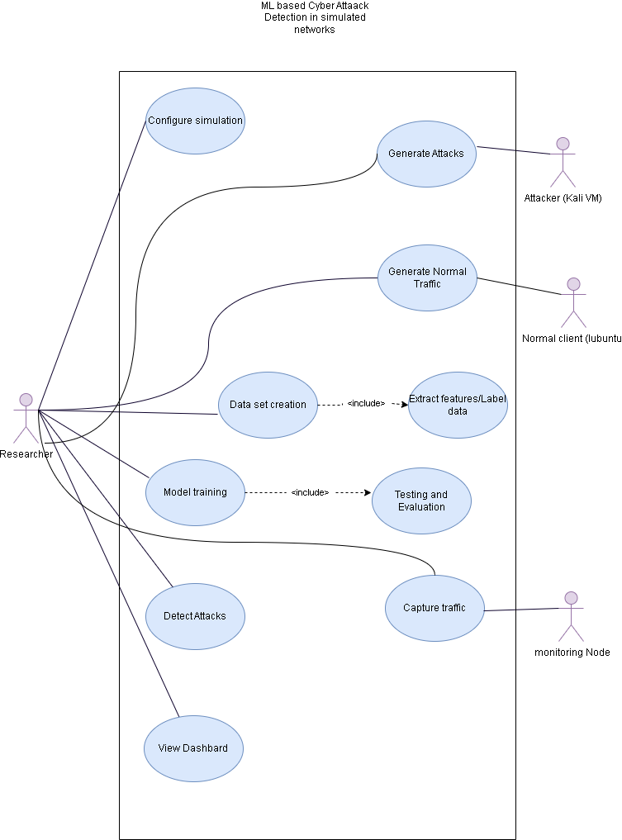
1.6.2 Usage Scenarios

1. Configure Simulation
Field | Description
Actor | Researcher
Pre condition | GNS3 and virtual machines are installed, network topology prepared.
Post condition | All devices in the simulated network are configured and running.
Flow of Events | 1. Open GNS3 and load topology.  2. Add ethernet hub, Legitimate-client VM, attacker VM, Victim-Server VM, monitoring node.  3. Assign interfaces and IP addresses.  4. Start nodes and verify connectivity.
Exception | VM fails to start, IP misconfiguration, link failure.

2. Generate Attacks
Field | Description
Actor | Attacker VM Kali, Researcher
Pre condition | Attacker VM connected and reachable.
Post condition | Malicious traffic is generated.
Flow of Events | 1. Connect to attacker VM.  2. Selects attack type (e.g., DoS, Nmap scan, brute-force).  3. Run attack tools.  4. Traffic flows through network.
Exception | Attack tools missing, network blocked.

3. Generate Normal Traffic
Field | Description
Actor | Legitimate Client, Researcher
Pre-condition | Client VM is connected and services are active.
Post-condition | Legitimate network traffic is generated.
Flow of Events | 1. Start client VM.  2. Access web/server services.  3. Generate normal user activity.
Exception | Client connection failure or service unavailable.

4. Capture Traffic
Field | Description
Actor | Monitoring node, Researcher
Pre condition | Simulation running.
Post condition | PCAP saved.
Flow of Events | - Start Monitoring node.  - Start Wireshark.  - Capture traffic.  - Stop and save PCAPs.
Exception | Packet loss, storage full.

5. Dataset Creation
Field | Description
Actor | Researcher
Pre condition | Raw PCAP files for normal and attack traffic are available.
Post condition | A clean and labeled CSV dataset is generated for machine learning model training.
Flow of Events | - Run the PCAP-to-CSV processing script.  - Load raw PCAP files collected from normal and attack traffic.  - Extract required network traffic features from the packets.  - Assign labels according to the traffic type.  - Combine normal and malicious traffic records into a single structured dataset.  - Save the final labeled dataset in CSV format.
Exception | Missing PCAP, corrupted file, incorrect labels, or script failure.

6. Model Training
Field | Description
Actor | Researcher
Pre condition | Labeled dataset available.
Post condition | Trained model saved.
Flow of Events | - Select ML algorithm.  - Split dataset.  - Train model.  - Evaluate model.  - Save model.
Exception | Insufficient memory, training or testing failure.

7. Detect Attacks
Field | Description
Actor | Researcher, IDS Monitor Node
Pre condition | Trained model and monitoring interface are available.
Post condition | Network traffic is classified as normal or malicious, and detection results are saved
Flow of Events | - Start the detection script on the IDS monitor node.  - The system monitors live network traffic.  - Packet information is processed into the input format required by the trained model.  - The model predicts the traffic category.  - The prediction is converted into a readable label using label mapping.  - The detection result is saved in the log file.
Exception | Script failure, data mismatch.

8. View Dashboard
Field | Description
Actor | Researcher, monitoring node
Pre-condition | Detection results and logs are available.
Post-condition | Dashboard displays alerts, logs, and visual statistics.
Flow of Events | 1. In monitoring node run Flask dashboard in browser.  2. Fetch live detection results, logs, and traffic statistics.  3. Display live alerts, attack statistics and packet tracking information.
Exception | Dashboard loading failure, missing data, or visualization error.

1.7 DEVELOPMENT METHODOLOGY
1.7.1 Chosen Methodology
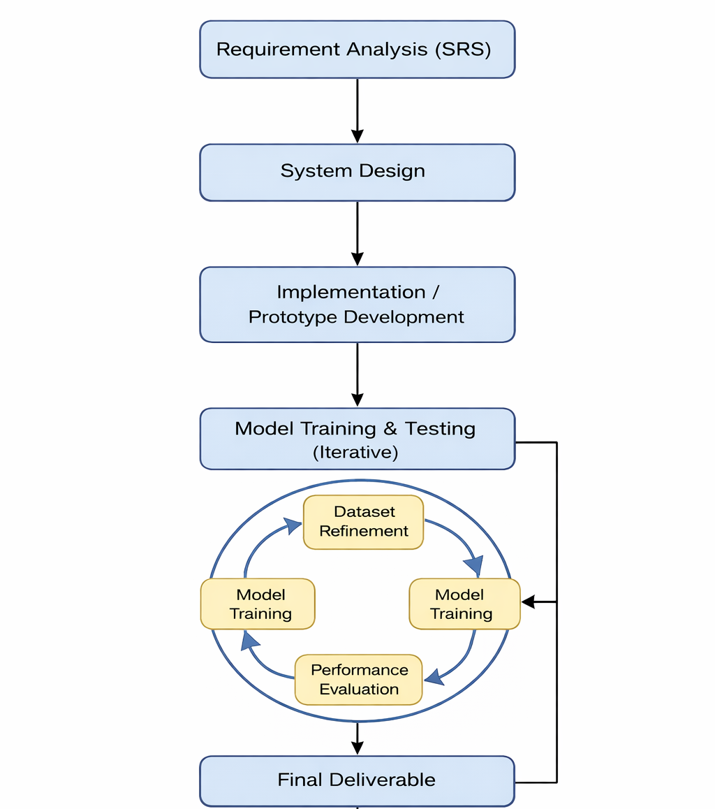
The project follows a hybrid VU Process Model combining Waterfall and Spiral methodologies.

1.7.2 Reasons for Chosen Methodology
The hybrid VU Process Model was chosen because the project contains both structured development tasks and iterative machine learning processes.
The Waterfall approach is suitable because the project phases such as simulation setup, attack generation, traffic capturing, and documentation follow a fixed sequence and require proper planning and completion before moving forward.
However, the machine learning part of the project requires multiple experiments, repeated model training, dataset refinement, and performance evaluation. Therefore, the Spiral approach is used to support continuous improvement and reduce risks related to low model accuracy or incorrect detection results.
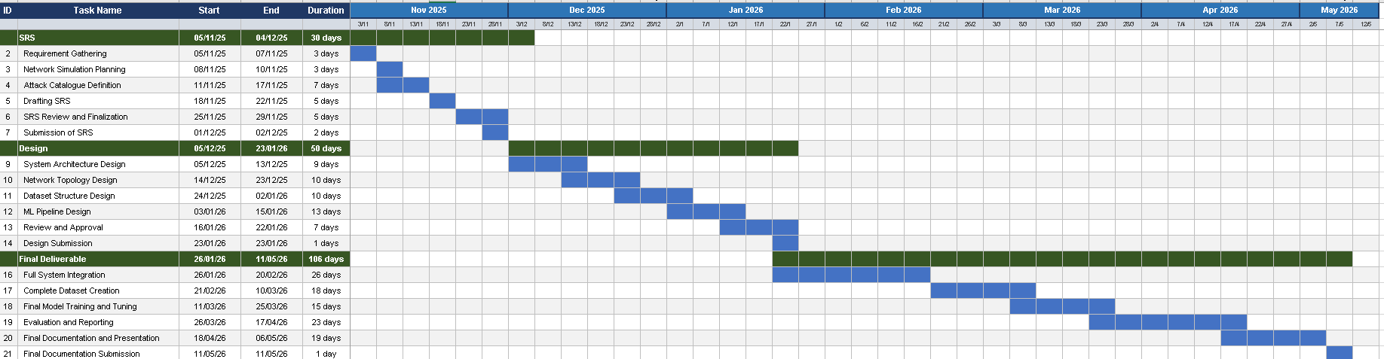
1.7.3 Work Plan (Gantt Chart)

1.7.4 Project Schedule (Submission Calendar)
This project spans approximately six months, from November 2025 to May 2026, and is structured across three formal submission phases: SRS (Requirements), Design, and Final Deliverable. Each phase builds on the previous one, progressing from problem definition and architecture through to full system implementation, dataset creation, ML model training, and final evaluation.
# | Submission Milestone | Deadline | Description
1 | SRS Document | 4 Dec 2025 | Requirements, simulation plan, and attack catalogue
2 | Design Document | 23 Jan 2026 | Architecture, topology, dataset structure, Network design
3 | Final Submission | 11 May 2026 | Final report, Final presentation, Final simulation setup lab.

CHAPTER 2
Designing the Project

2 .1 INTRODUCTION
This chapter explains the system design, network architecture, workflow, and interaction between system components. It serves as blueprint for the actual setup.

2.2 PURPOSE
The purpose of the designing phase is to provide the detailed architectural and technical design of the “ML Based Cyber Attack Detection in Simulated Networks” system. It describes how different system components interact within the simulated environment and explains the implementation approach for traffic generation, packet capturing, machine learning based attack detection, and real-time monitoring.
2.3 SCOPE

The scope of this design phase includes the technical design and implementation planning of a simulated cyber security environment developed using GNS3 and VMware Workstation. The system consists of Kali Linux, Ubuntu VM, Lubuntu VM and ethernet hub nodes connected through a virtual network for generating and analyzing both normal and malicious traffic. The design phase will help in identifying the role of each component in the system.
The scope of this design document includes:
- Network topology design
- System architecture design
- Sequence diagrams and workflows
- Data flow representation
- Machine learning integration
- Real-time traffic monitoring
- Flask dashboard design
- Test case planning
2.4 DEFINITIONS, ACRONYMS AND ABBREVIATIONS

Term | Description
IDS | Intrusion Detection System
CSV | Comma Separated Values
GUI | Graphical User Interface
HTTP | Hypertext Transfer Protocol
Flask | Python web framework
VM | Virtual Machine
2.5 NETWORK DESIGN AND TOPOLOGY

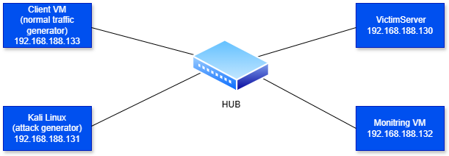
This network follows a star topology, where all virtual machines connect through a central hub. The setup consists of four nodes: a Client VM that generates legitimate network traffic to simulate normal user behavior, a Kali Linux VM that acts as the attacker by generating malicious traffic such as DoS attacks, port scans, and brute-force attempts, a Victim Server, and a Monitoring VM equipped with Wireshark and an ML-based detection engine that passively captures and analyzes all traffic flowing through the network. All devices communicate through the central hub, which forwards traffic between nodes, while the Monitoring VM silently observes everything capturing packets, labeling traffic, and feeding data into the machine learning pipeline for attack detection and classification.

2.6 ARCHITECTURAL REPRESENTATION (ARCHITECTURE DIAGRAM)

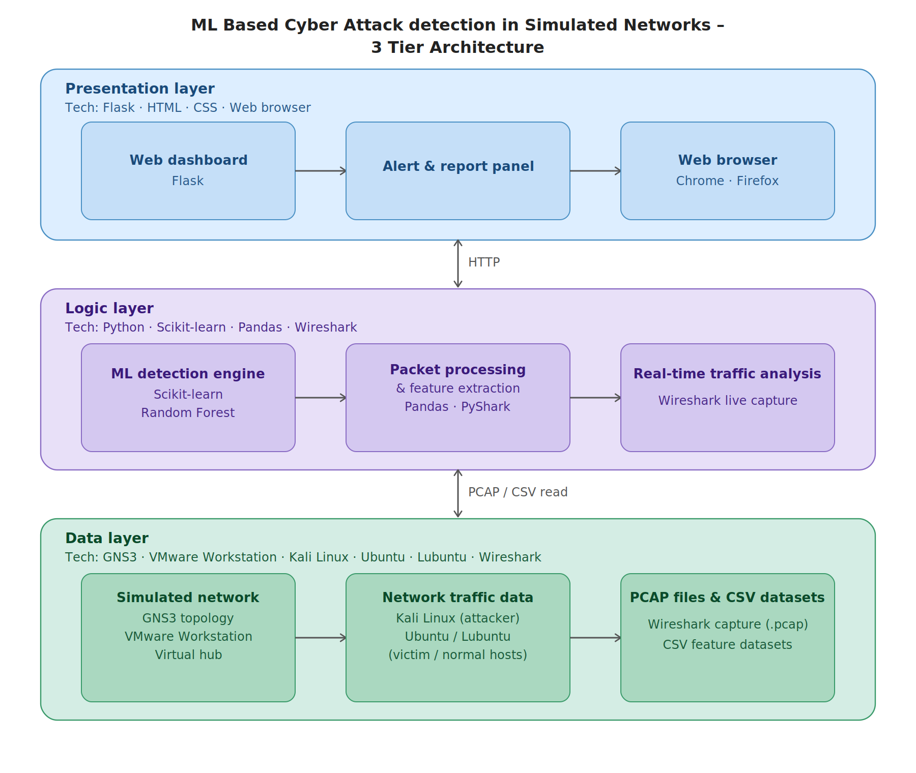

2.7 DYNAMIC MODEL: SEQUENCE DIAGRAMS

Configure Simulation
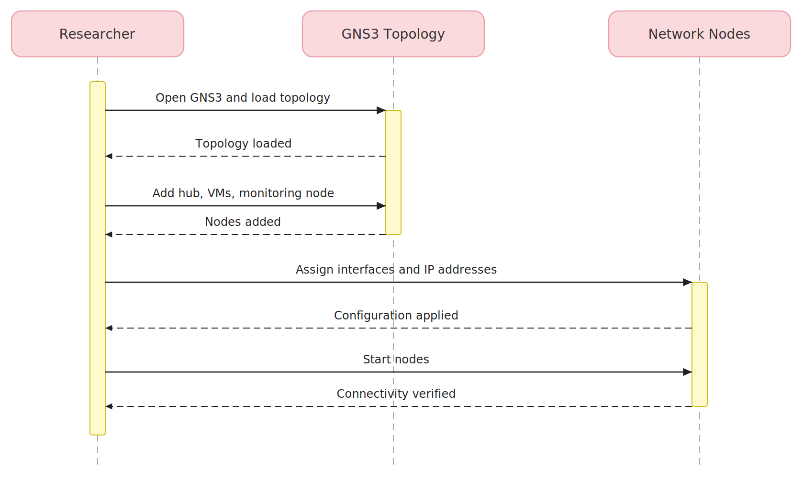

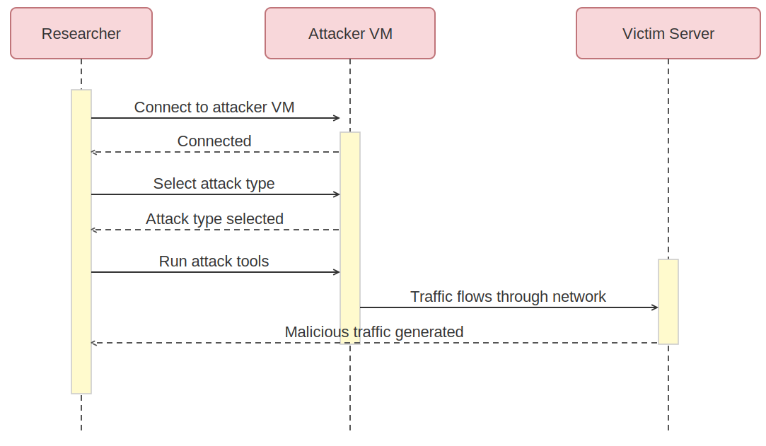
2. Generate Attacks

3. Generate Normal traffic
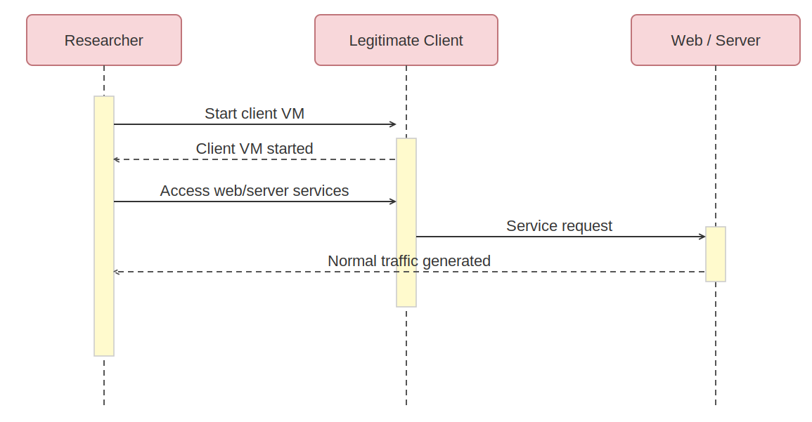

4. Capture Traffic
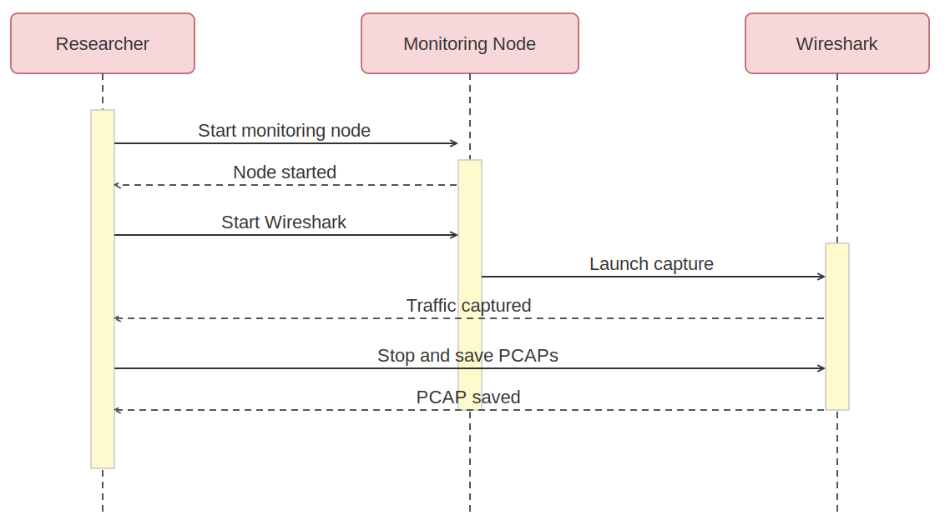
5. Dataset Creation

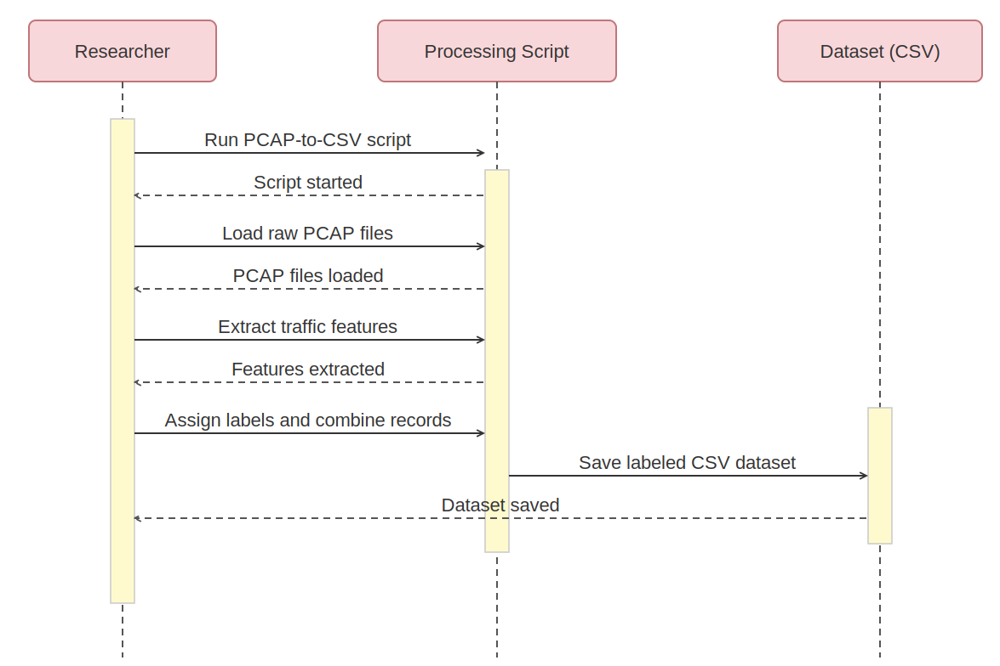

6. Model Training

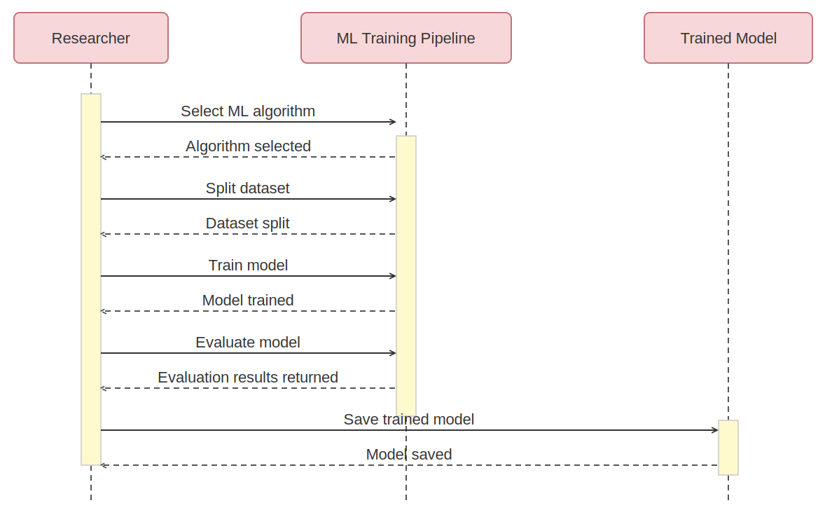

7. Detect Attacks

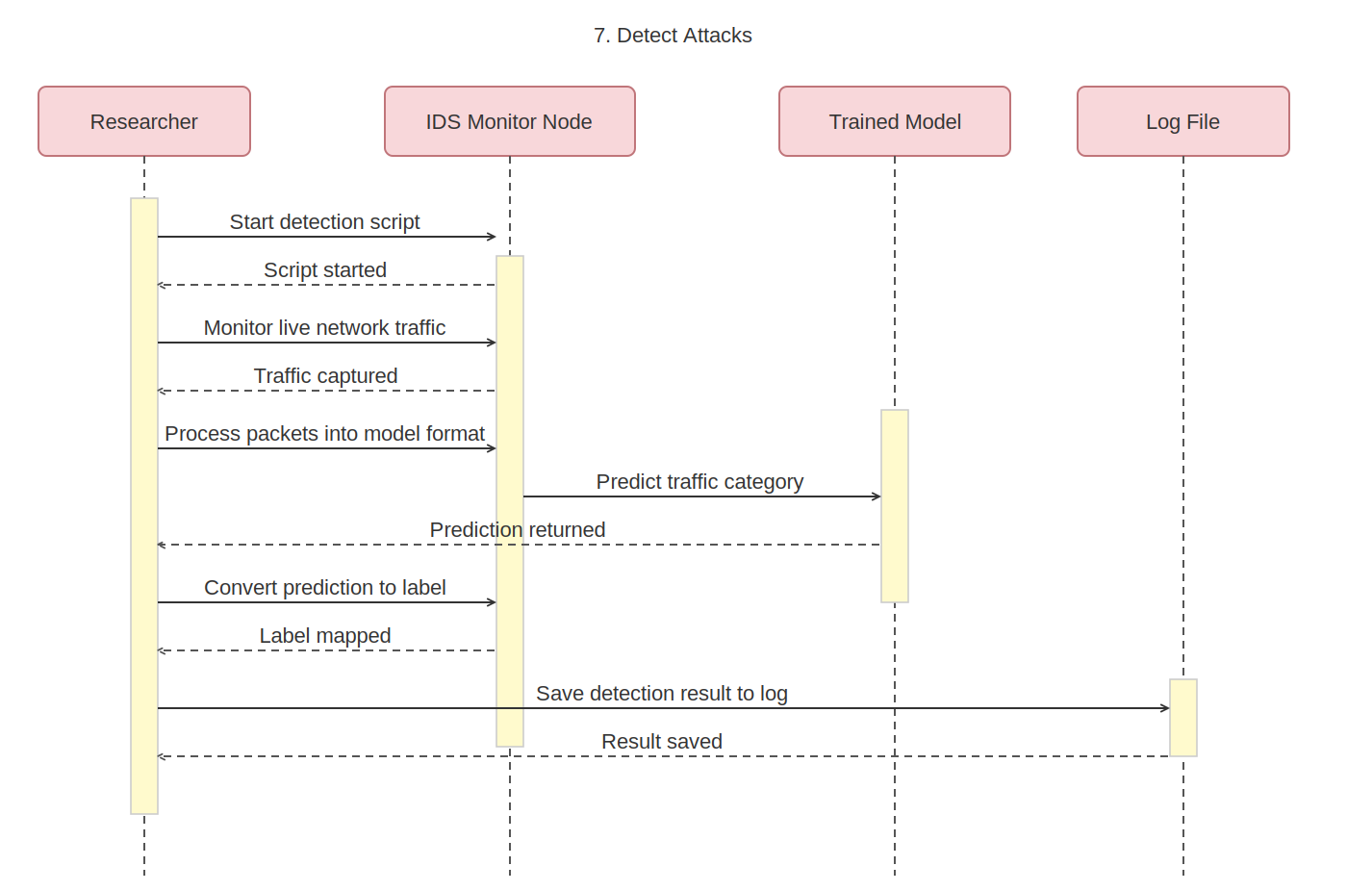

8. View Dashboard

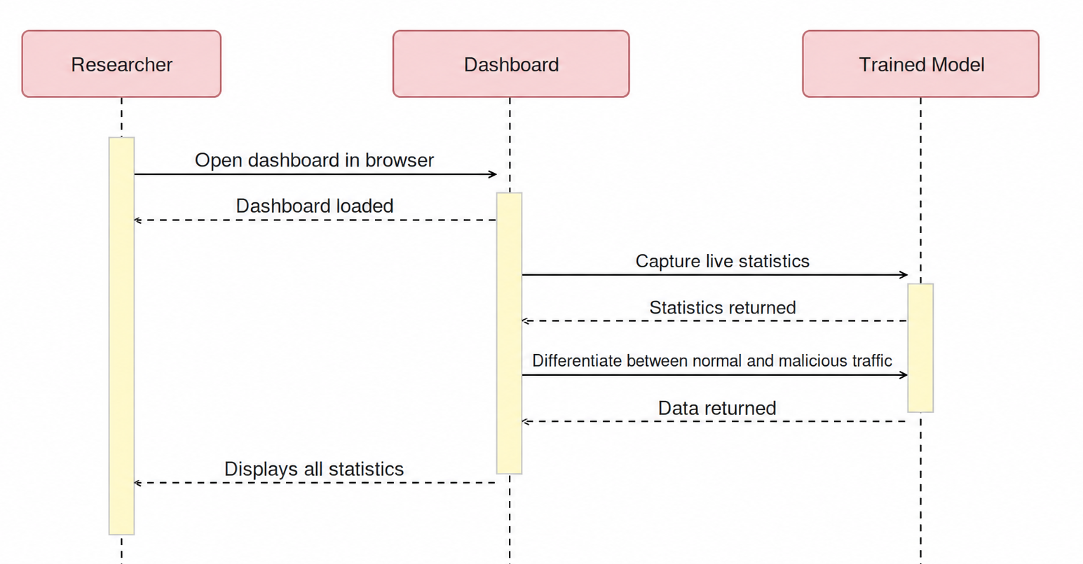
2.8 TEST CASES

Test Case ID | TC-01
Use Case | Configure Simulation
Actor | Researcher
Description | Verify that the simulated network environment is configured successfully
Pre-Conditions | GNS3 installed, required VMs available
Test Steps | 1. Launch GNS3  2. Add client, server, attacker, and monitoring VMs  3. Connect all nodes using a virtual hub
Expected Result | Network topology is created and all nodes are connected
Status | Pass

Test Case ID | TC-02
Use Case | Generate Attacks
Actor | Attacker (Kali Linux)
Description | Verify that malicious traffic is generated
Pre-Conditions | Kali Linux VM running
Test Steps | 1. Launch Nmap scan  2. Perform brute-force  3.Perform Dos Attack  4. launch SYN flood attack
Expected Result | Malicious traffic is generated and sent to the server
Status | Pass

Test Case ID | TC-03
Use Case | Generate Normal Traffic
Actor | Normal Client, Researcher
Description | Verify that legitimate network traffic is generated successfully from the client VM
Pre-Conditions | Client VM is connected to the simulated network and required services are active
Test Steps | 1. Start the client VM  2. Verify network connectivity  3. Access web/server services from the client VM  4. Perform normal user activities such as browsing or sending requests
Expected Result | Legitimate network traffic is generated and visible in the simulated network
Status | Pass

Test Case ID | TC-04
Use Case | Capture Traffic
Actor | Traffic Monitor (Wireshark)
Description | Verify packet capture of network traffic
Pre-Conditions | Network traffic is active
Test Steps | 1. Start Wireshark capture  2. Observe packets
Expected Result | PCAP file containing traffic is generated
Status | Pass

Test Case ID | TC-05
Use Case | Dataset Creation
Actor | Researcher
Description | Verify that the script converts PCAP traffic files into a labeled CSV dataset for model training.
Pre-Conditions | Normal and attack PCAP files are available, and the processing script is ready.
Test Steps | - Run the dataset creation script.  - Check that traffic features are extracted correctly.  - Verify that labels are assigned to each traffic record  - Confirm that the final CSV file is generated.
Expected Result | Structured dataset created successfully
Status | Pass

Test Case ID | TC-06
Use Case | Model Training
Actor | Researcher
Description | Verify ML model training
Pre-Conditions | Dataset available
Test Steps | 1. Load dataset  2. Train variety of ML models.
Expected Result | Trained ML model is generated
Status | Pass

Test Case ID | TC-07
Use Case | Detect Attacks
Actor | Researcher
Description | Verify that the trained ML model correctly classifies network traffic as normal or malicious
Pre-Conditions | Trained model and traffic dataset are available
Test Steps | 1. Load the trained ML model  2. Run the detection script  3. Observe classification results  4. Confirm that the detection result is saved in the log file.
Expected Result | Traffic is classified successfully and detection results/logs are generated
Status | Pass

Test Case ID | TC-08
Use Case | View Dashboard
Actor | Researcher, monitoring node
Description | Verify that the Flask dashboard displays alerts, logs, and attack statistics correctly
Pre-Conditions | Detection results and log files are available
Test Steps | - Start the monitoring server  - Open dashboard in web browser  - Generate traffic in the simulated network.  - Verify that the dashboard shows current traffic status.  - Check alerts, attack statistics, and packet tracking information
Expected Result | Dashboard loads successfully and displays alerts, logs, and visual statistics
Status | Pass

CHAPTER 3
Development

3.1 INTRODUCTION
This chapter documents the complete development and implementation phase of the project. It covers all configurations, setups, and procedures carried out to build a fully functional Cyber Attack Detection System within a controlled virtual environment. The development was structured into distinct stages: environment setup, network topology configuration, normal and malicious traffic generation, packet capture and preprocessing, machine learning model training, and finally the deployment of a real-time Flask-based monitoring dashboard.
Each section below provides step-by-step documentation of what was implemented, which tools and commands were used, and what results were observed. Screenshots captured during the development process are referenced throughout to validate each implementation step.

3.2 ENVIRONMENT SETUP AND TOOLS USED
The development environment was built entirely using virtualization software. The following tools and platforms formed the foundation of the project infrastructure:
Tool / Platform | Purpose
GNS3 | Network simulation environment for connecting and managing virtual machines
VMware Workstation | A virtualization platform used to create, run, and manage multiple virtual machines
Kali Linux VM | Used to generate all malicious traffic
Ubuntu VM | Victim server, hosts Apache2, SSH (OpenSSH), and vsftpd services.
Lubuntu VM | Legitimate client, generates normal network traffic
Ubuntu VM | IDS Monitor: runs Wireshark, Python ML engine, and Flask dashboard
Wireshark | Packet capture tool on the monitoring node
Python 3 + Scikit-learn | Machine learning model training and classification
Scapy, pandas, joblib & matplotlib | Python libraries used for network packet handling, data processing, model storage, and data visualization.
Flask (Python) | Web framework for the real-time monitoring dashboard
hping3, Hydra, Nmap | Attack generation tools on Kali Linux

3.3 NETWORK TOPOLOGY CONFIGURATION

3.3.1 Topology Design
The simulated network follows a star topology where all four virtual machine nodes connect through a single central Ethernet hub (Hub).
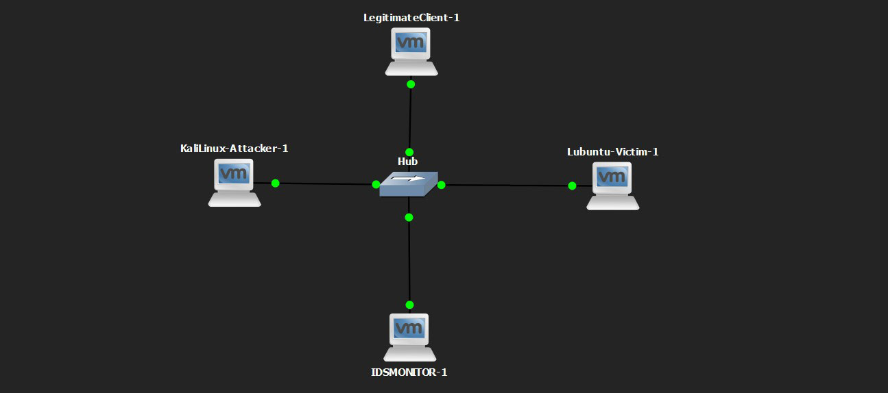

3.3.2 IP Address Assignments
Each node in the network was assigned a static IP address within the 192.168.188.0/24 subnet. Static addressing was used to ensure consistent identification of each node during traffic analysis and ML classification. The addresses were configured as follows:
Node | IP Address
Monitoring Node | 192.168.188.132
Kali Linux-Attacker | 192.168.188.131
Legitimate Client | 192.168.188.133
Victim-Server | 192.168.188.130
NAT / Gateway | 192.168.188.1
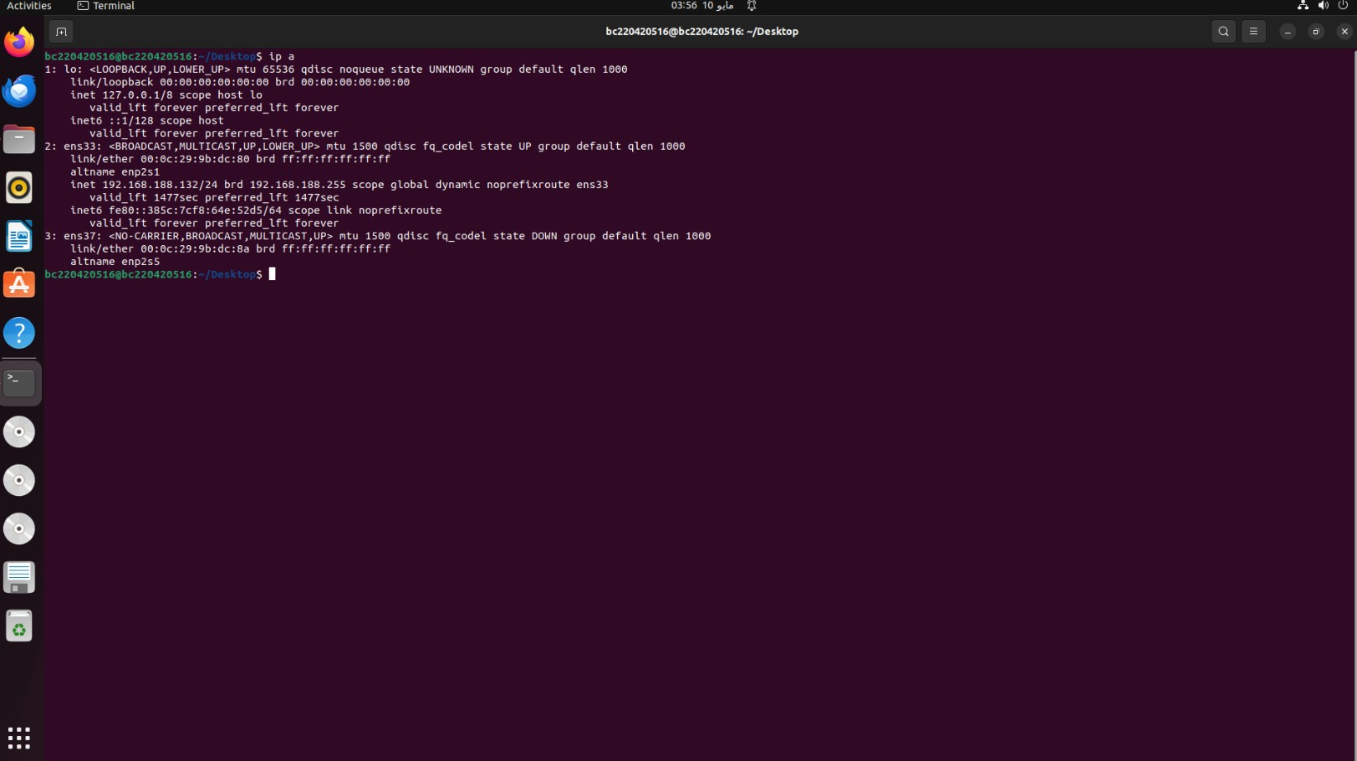
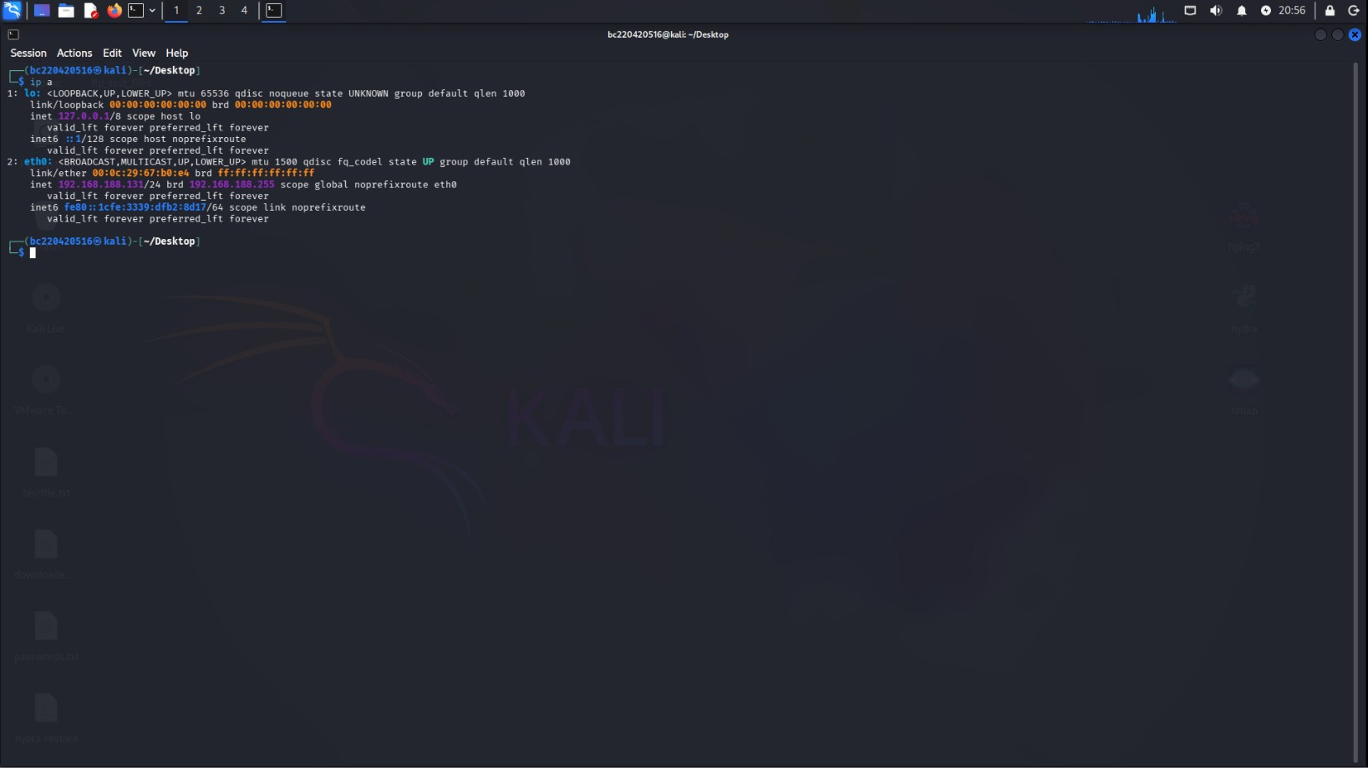
Monitoring node

Kali Attacker VM
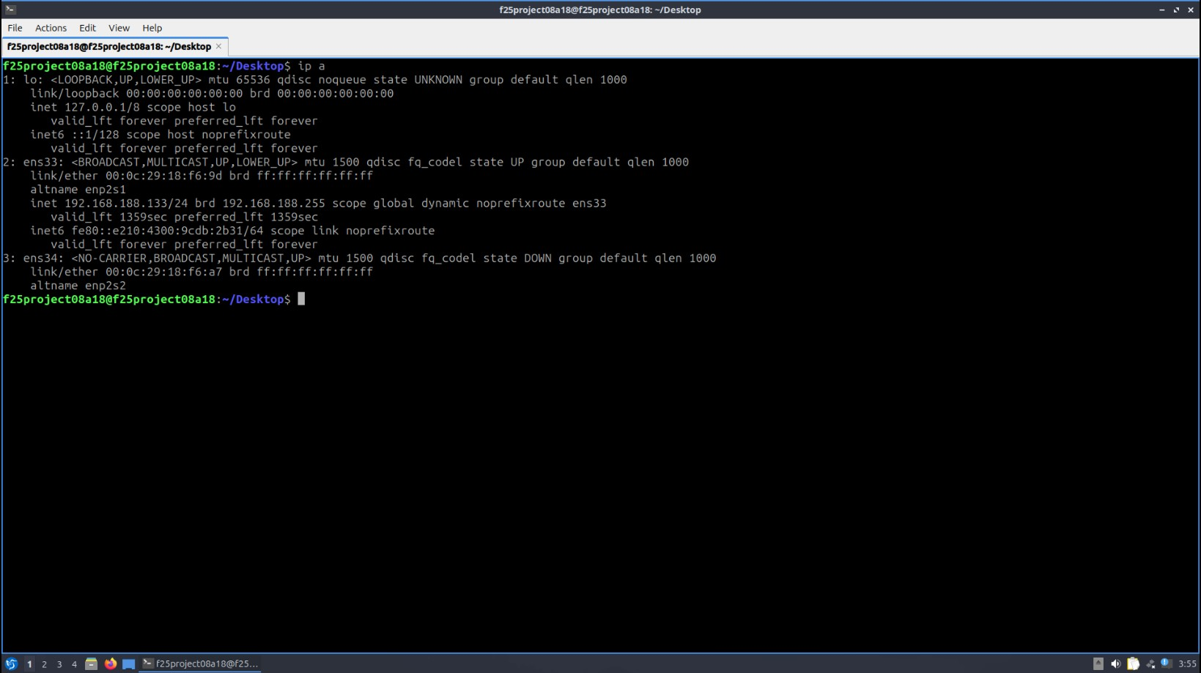

Legitimate Client
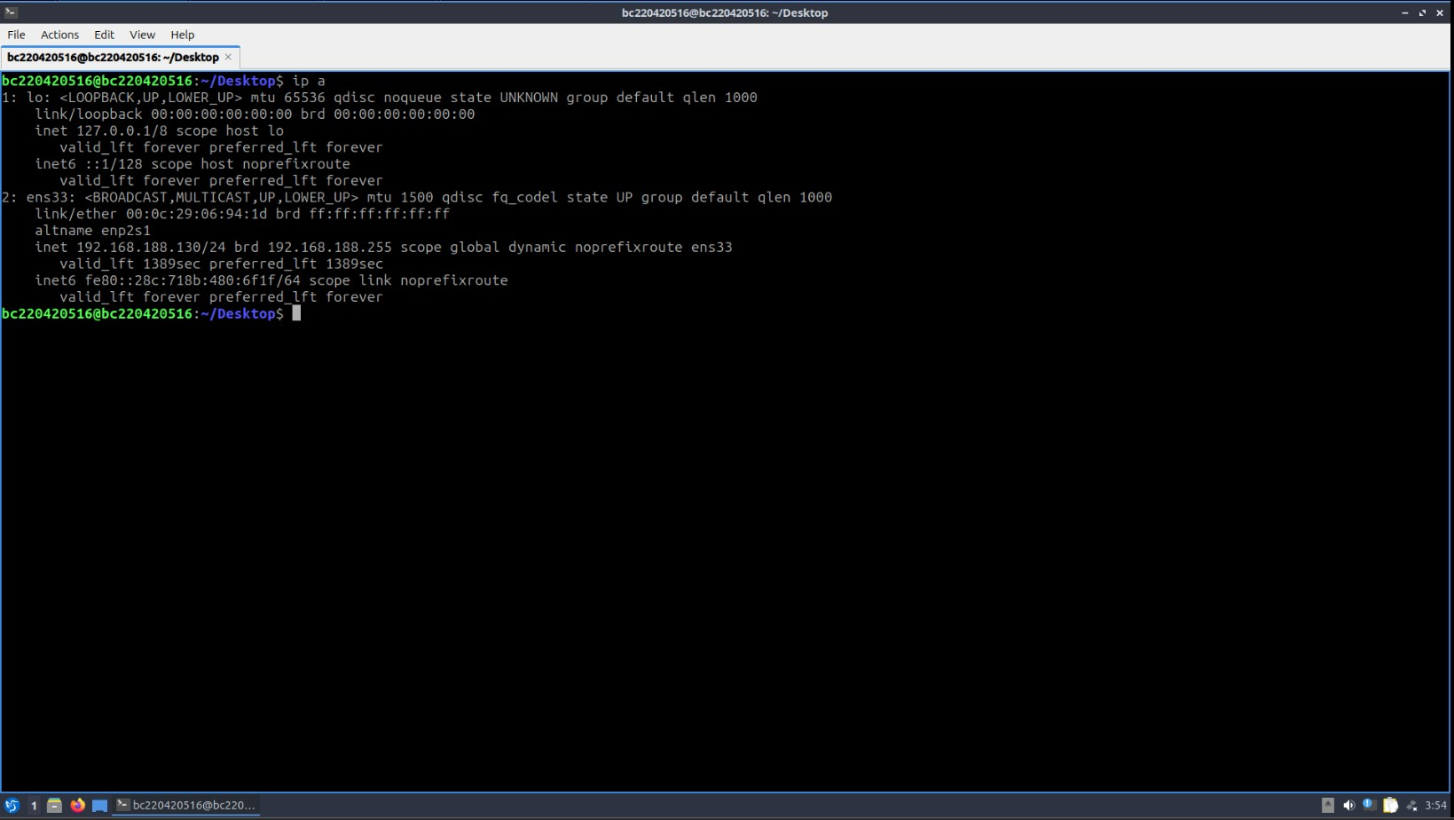

Victim Server

3.3.3 Berkeley Packet Filter (BPF) Configuration
To ensure that the IDS Monitor captured only relevant internal lab traffic, a Berkeley Packet Filter (BPF) was applied inside the IDS packet-capturing module. The filter excluded traffic generated by the GNS3 VM, the IDS Monitor itself, the default gateway, NAT/management networks, multicast traffic, and broadcast noise. This helped reduce unnecessary background packets without interrupting communication between the lab machines.
The BPF filter rule used in the IDS packet-capturing module was:
“BPF_FILTER = (
"ip and "
"(host 192.168.188.130 or host 192.168.188.131 or host 192.168.188.133) "
"and not host 192.168.188.132 "
"and not host 192.168.188.128 "
"and not host 192.168.188.1 "
"and not net 192.168.17.0/24 "
"and not net 192.168.59.0/24 "
"and not net 192.168.187.0/24 "
"and not net 224.0.0.0/4 "
"and not host 255.255.255.255"
)

3.4 VICTIM SERVER CONFIGURATION
The Victim Server (IP: 192.168.188.130) was configured with three network services that would serve as targets for both normal and malicious traffic. This made the server realistic in simulating a production environment where multiple services run simultaneously.

3.4.1 Services Configured on Victim Server
Service | Protocol
Apache2 Web Server | HTTP (Port 80)
OpenSSH Server | SSH (Port 22)
vsftpd FTP Server | FTP (Port 21)

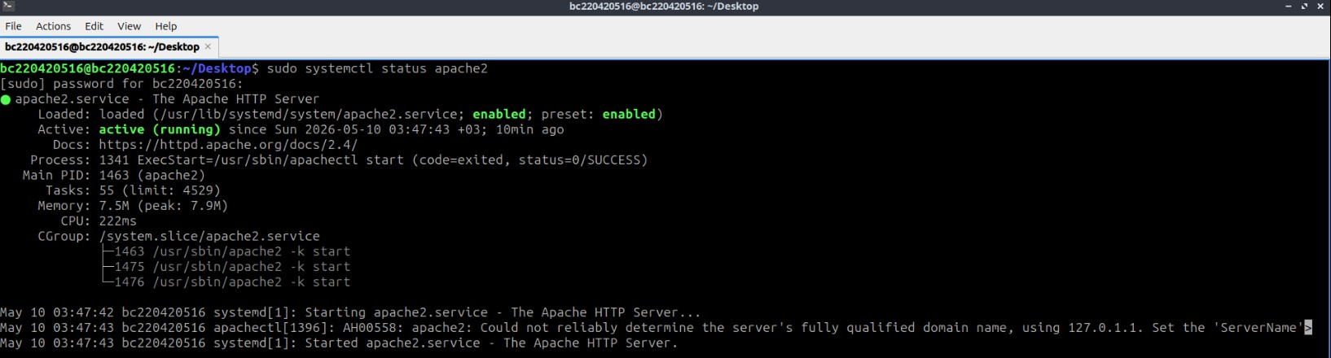
Victim-server-apache2-status
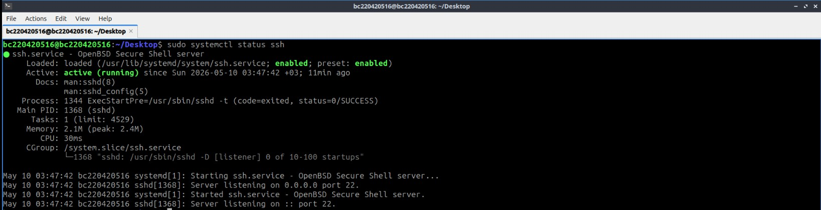
Victim-server-ssh-status
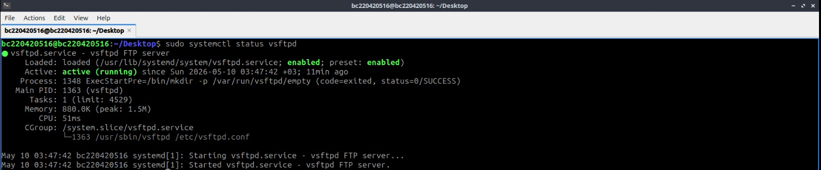
Victim-server-vsftpd-status

All three services were verified to be active and running using the 'systemctl status' command on the Victim Server. Apache2 was confirmed serving on port 80, SSH on port 22, and vsftpd on port 21. These services provided the necessary attack surface for traffic generation in subsequent stages.

3.5 NORMAL TRAFFIC GENERATION
Three types of normal traffic were generated from the Legitimate Client (IP: 192.168.188.133) targeting the Victim Server.

3.5.1 HTTP Traffic
HTTP traffic was generated by sending repeated curl requests from the Legitimate Client to the Apache2 web server running on the Victim Server at 192.168.188.130.
Command used:
for i in {1..30}; do curl http://192.168.188.130 > /dev/null; sleep 1; done
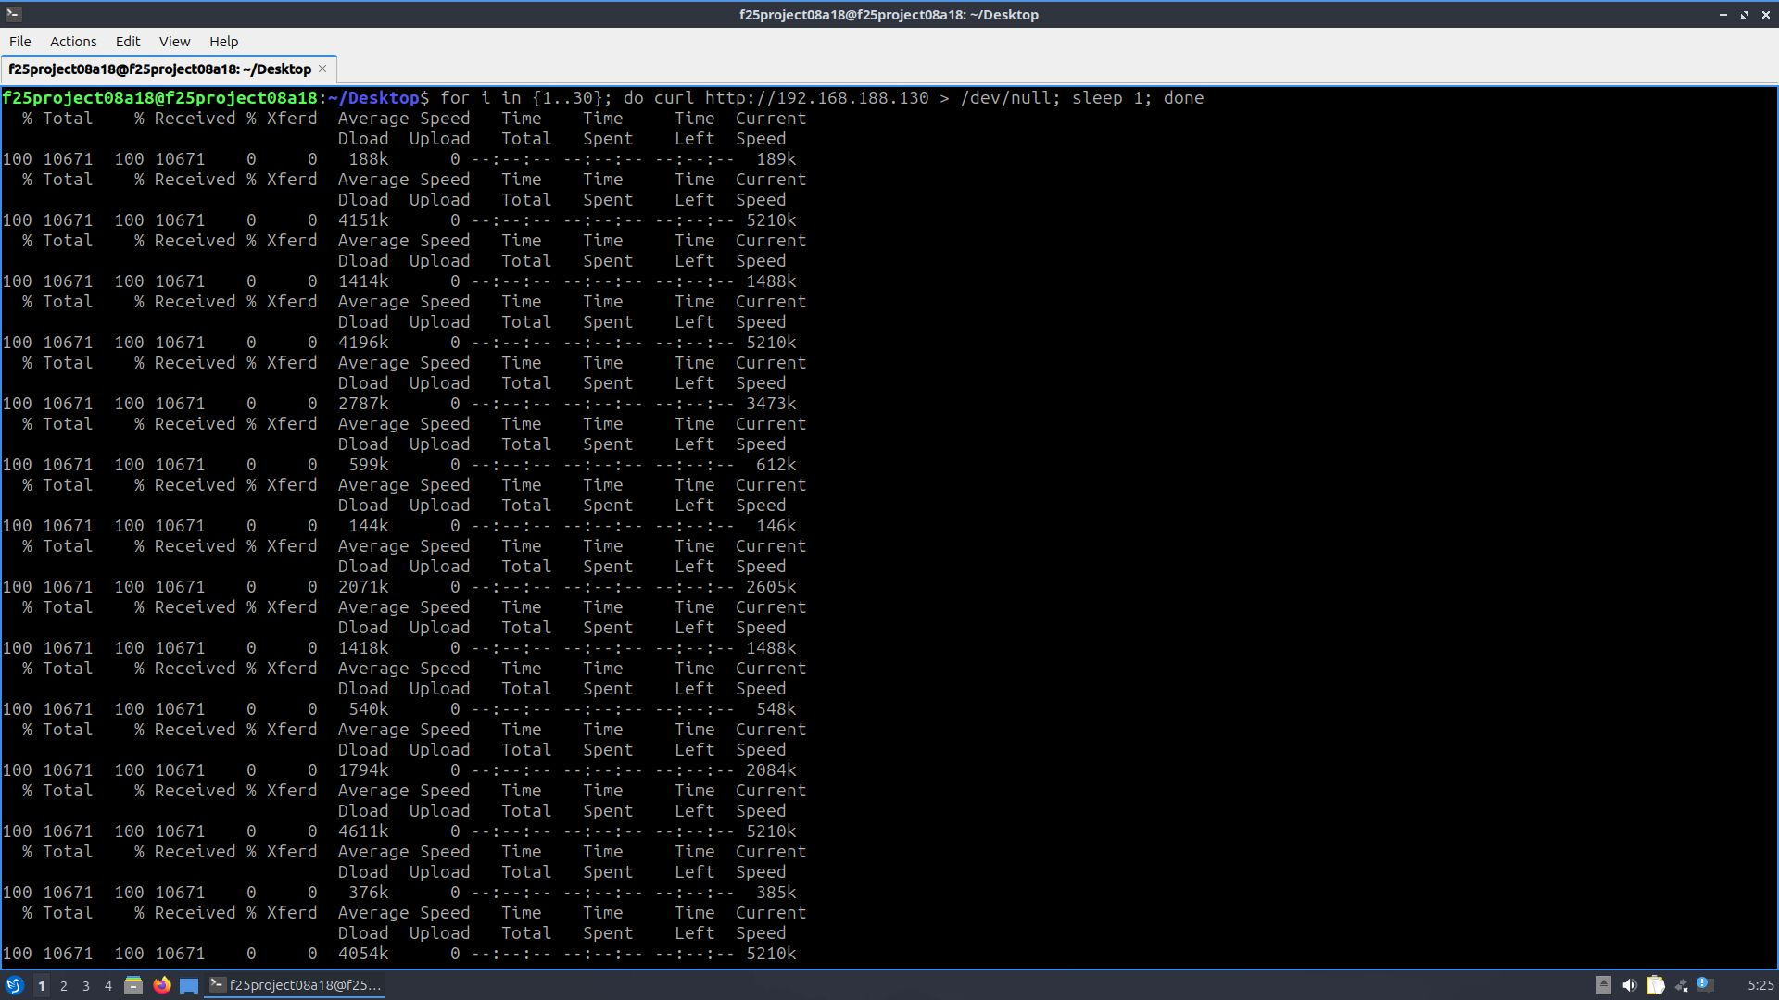
Http Traffic Initiation

3.5.2 SSH Traffic
SSH traffic was generated using a custom shell script (ssh1.sh) that established multiple SSH sessions to the Victim Server from the Legitimate Client. The script was designed to simulate normal SSH user behavior by performing 7 stages of interaction: initial connections and handshakes, interactive commands with small keystrokes, and subsequent session phases.
Command used:
./ssh1.sh
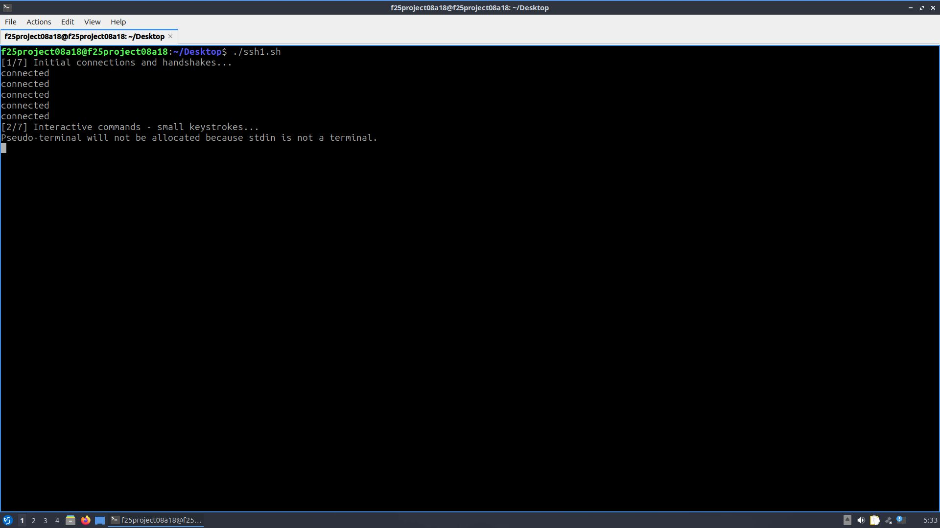
SSH Traffic Initiation

3.5.3 FTP Traffic
FTP traffic was generated by transferring and downloading a batch of 100 text files from the Legitimate Client to the Victim Server's vsftpd service.
Commands used:
ftp 192.168.188.130 → prompt → mput *.txt
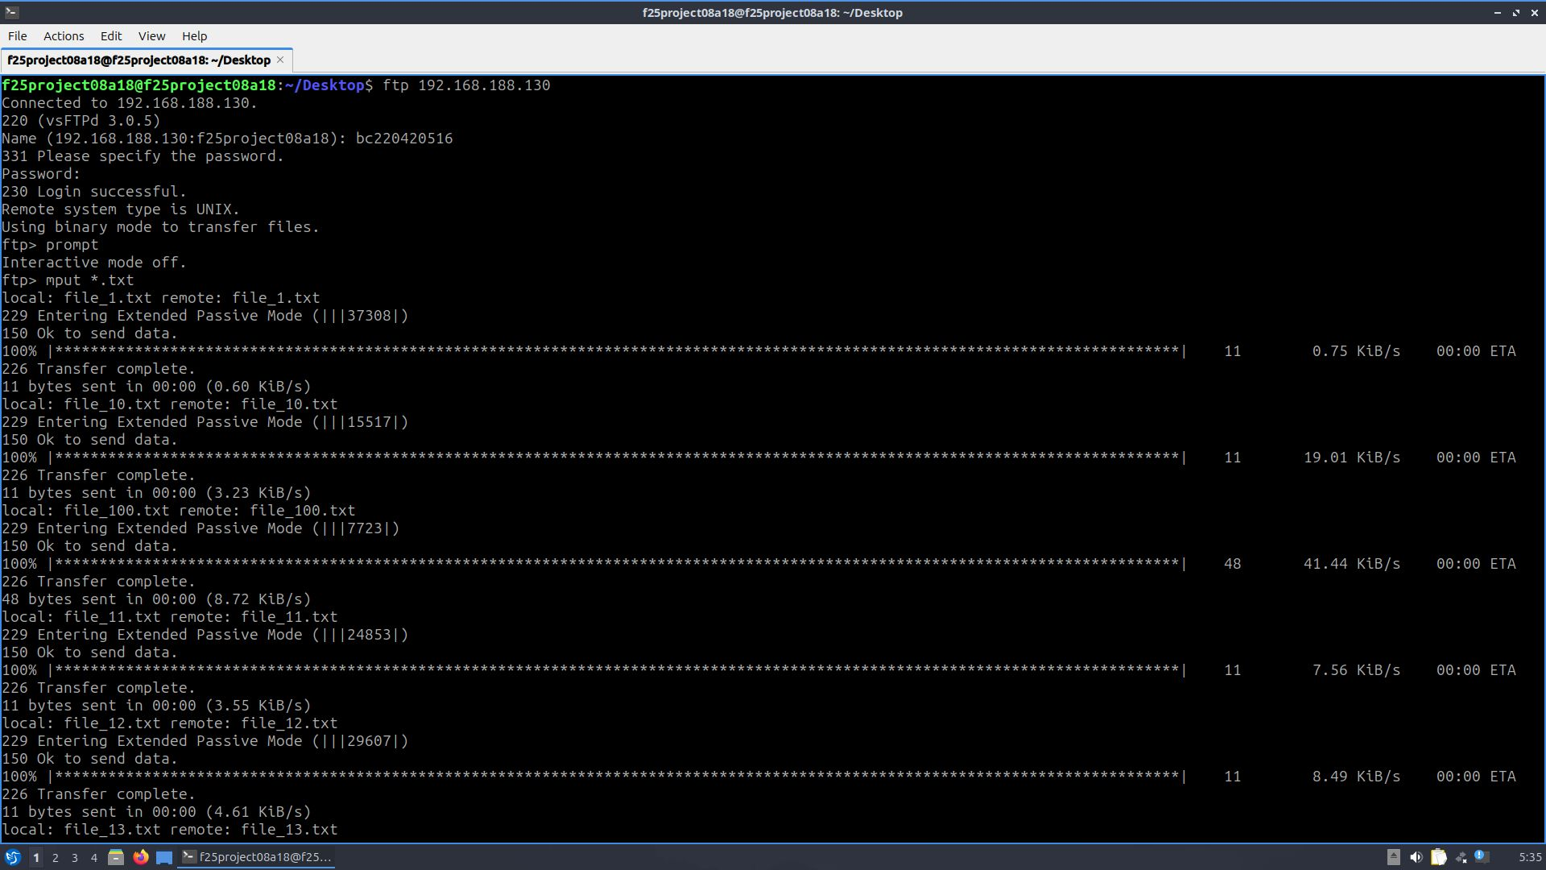
ftp Traffic Initiation


ftp Files Received

3.6 ATTACK TRAFFIC GENERATION

Attack traffic was generated from the Kali Linux VM (IP: 192.168.188.131) targeting the Victim Server (192.168.188.130). Four distinct attack types were implemented, each representing a different category of cyber threat commonly encountered in real networks.

3.6.1 SYN Flood Attack (TCP DoS)

A SYN Flood attack was performed using hping3 in flood mode. This attack exploits the TCP three-way handshake by sending a continuous stream of SYN packets without completing the connection, exhausting the server's connection table. The attack was directed at port 80 (Apache2 web service).
Command used: sudo hping3 -S --flood -p 80 192.168.188.130

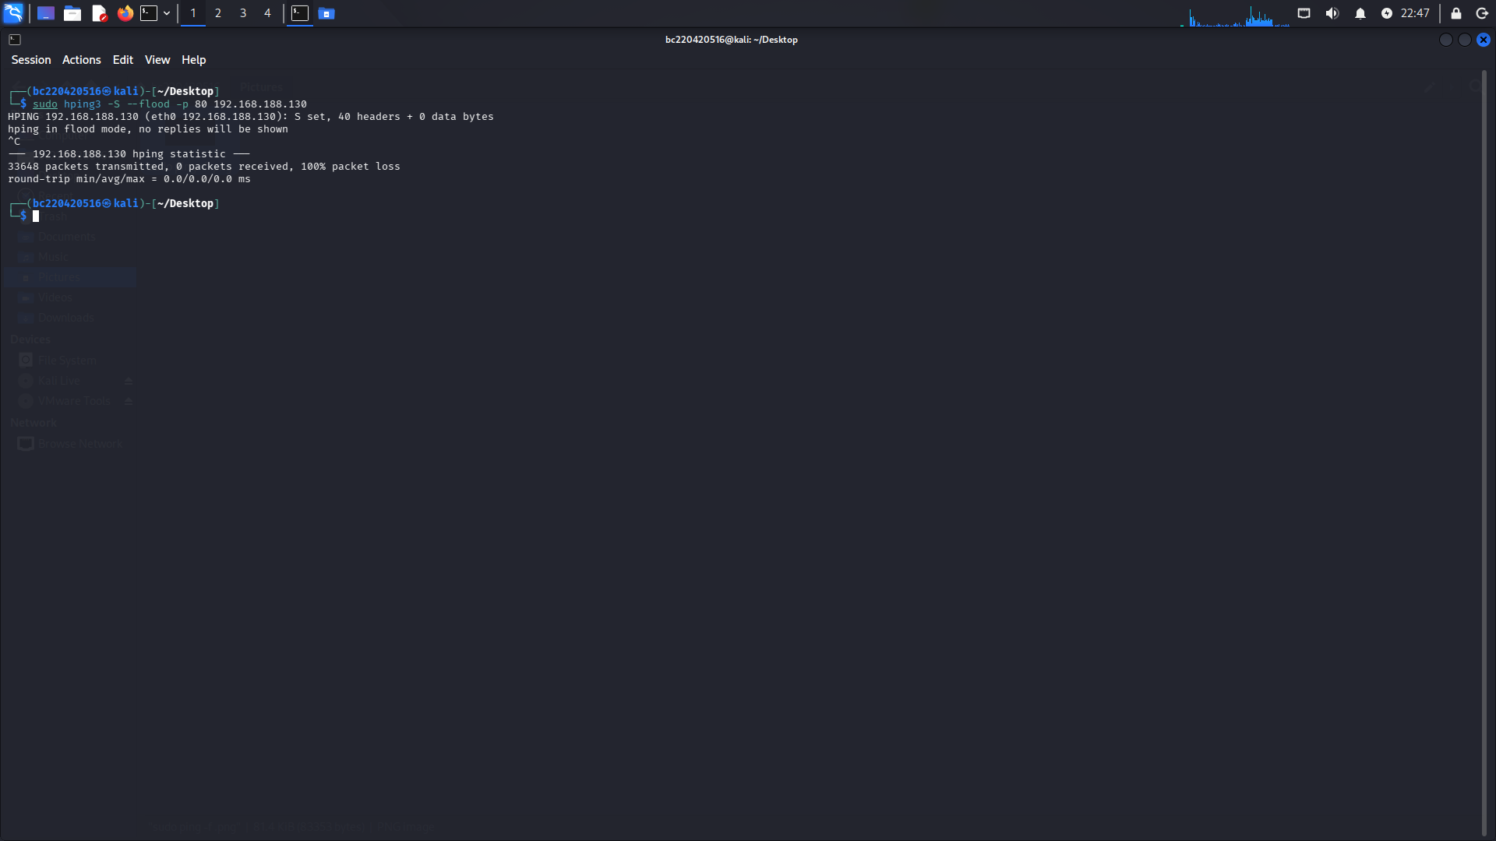
SYN Flood Attack Initiation

3.6.2 Brute Force Attack (SSH)
A brute force attack against the SSH service on the Victim Server was executed using the Hydra password cracking tool. Hydra attempts multiple username/password combinations in parallel, simulating a real-world credential stuffing or dictionary attack.
Command used:
hydra -l bc220420516 -P passwords.txt ssh://192.168.188.130

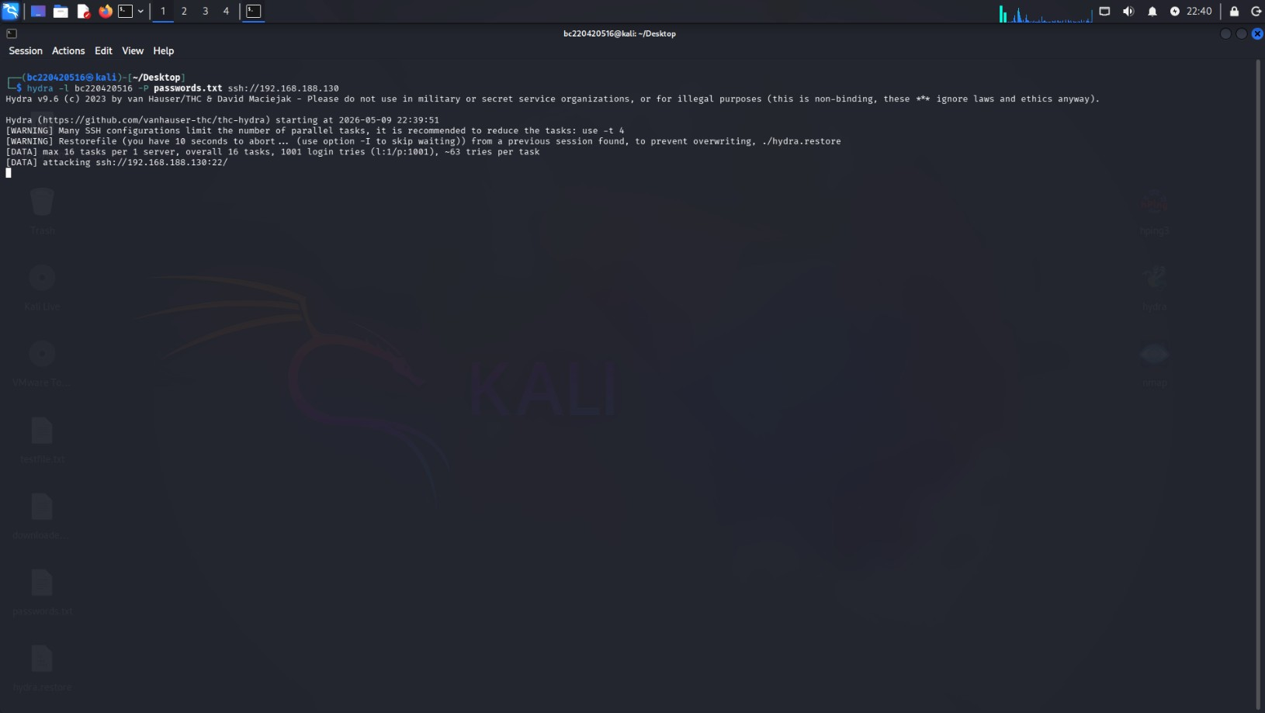
Brute Force Attack Initiation

3.6.3 Ping DoS / ICMP Flood
An ICMP-based Denial of Service attack (Ping DoS) was executed using hping3 to flood the Victim Server with ICMP echo request packets. This attack generates a large volume of ICMP traffic intended to overwhelm the target's network processing capability.
SYNDOS Attack Initiation

3.6.4 Nmap Port Scan

Network reconnaissance was performed using Nmap, which scans for open ports and running services on the target host. Nmap scanning is one of the most common precursors to a cyber attack, making it an important traffic class for the IDS to detect.

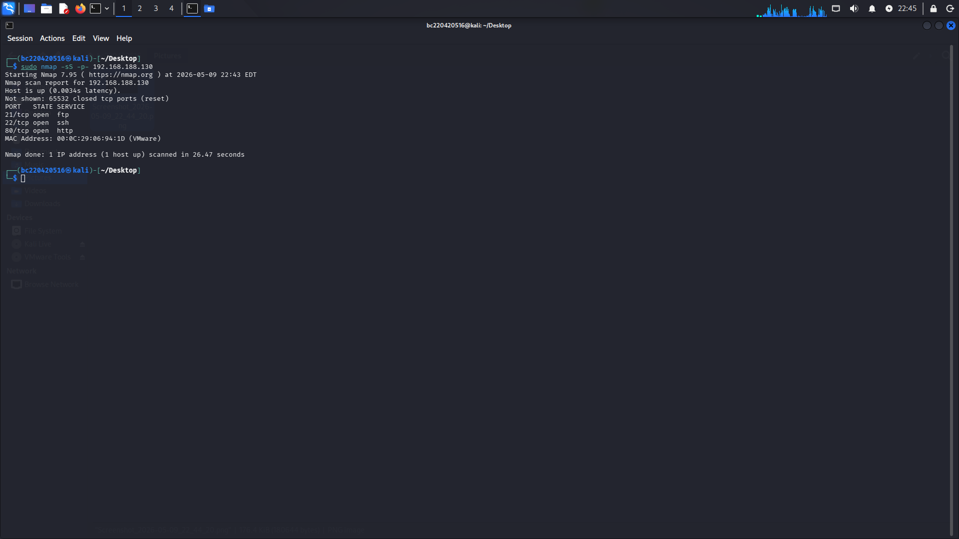
NmapScan Attack Initiation

3.7 TRAFFIC CAPTURE AND PCAP FILE MANAGEMENT

All network traffic both normal and malicious was captured on the Monitoring node (192.168.188.132) using Wireshark. The BPF filter configured in Section 3.3.3 ensured that only relevant simulation traffic was captured, excluding management and hypervisor traffic.
Separate PCAP files were saved for each traffic type to maintain clear labeling for the dataset creation phase. The following PCAP files were collected:
PCAP File | Traffic Type
normal_ping.pcap | Normal ICMP ping traffic
normal_http.pcap | Normal HTTP web traffic
normal_ssh.pcap | Normal SSH session traffic
normal_ftp.pcap | Normal FTP file transfer traffic
attack_ping_dos.pcap | ICMP Ping DoS flood
attack_syn_flood.pcap | SYN Flood TCP DoS
attack_nmap_scan.pcap | Nmap port scan reconnaissance
attack_bruteforce.pcap | SSH Brute Force (Hydra)
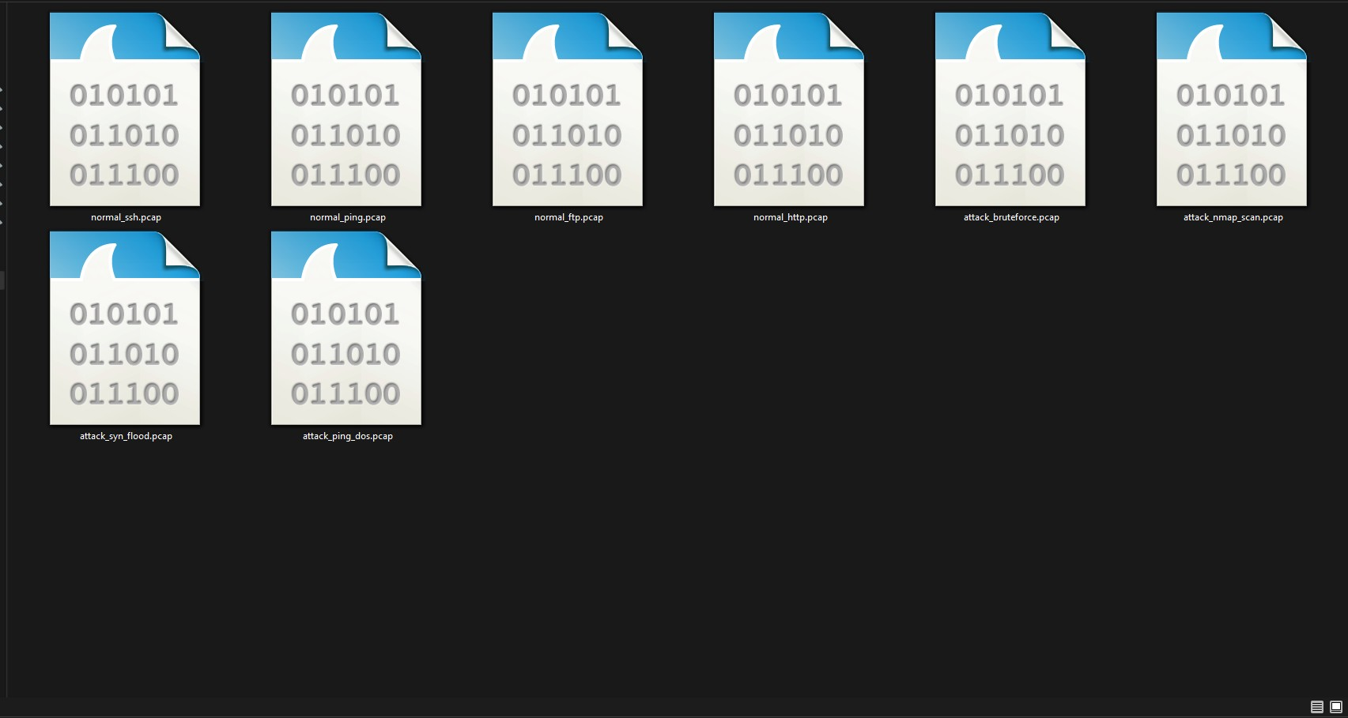
PCAPs Directory

3.8 DATA PREPROCESSING AND DATASET CREATION
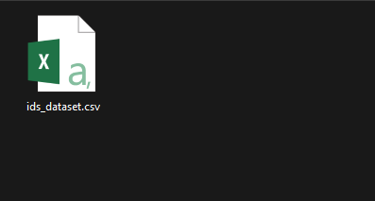
Raw PCAP files cannot be directly fed into machine learning models. A custom Python script (pcap_to_csv.py) was developed to extract meaningful network features from each PCAP file, label the records, and merge them into a single structured CSV dataset suitable for ML training.

3.8.1 PCAP to CSV Conversion
The pcap_to_csv.py script was executed on Windows PowerShell in the project directory. It reads each PCAP file, extracts packet-level features, assigns a class label based on the traffic type, and appends the records to a combined output dataset.
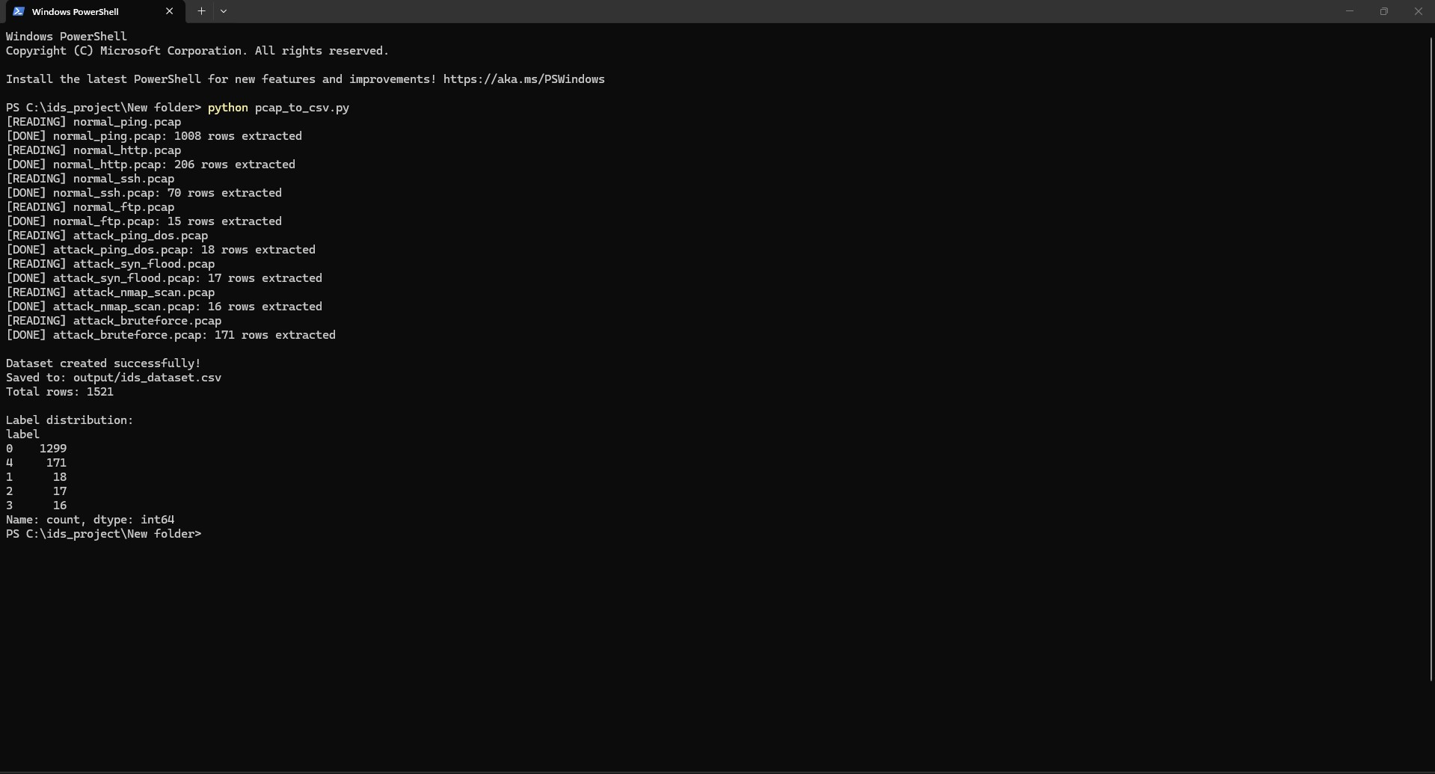
PCAP to CSV output
The script processed all eight PCAP files sequentially and produced the following combined dataset:
- Total rows extracted: 1,521
- Label 0: Normal traffic: 1,299 records(ping, http, SSH, ftp)
- Label 1: Ping DoS: 18 records
- Label 2: SYN Flood: 17 records
- Label 3: Nmap Scan: 16 records
- Label 4: Brute Force: 171 records

3.8.2 Dataset Label Distribution
The label distribution reflects the real-world imbalance commonly found in network traffic datasets, where normal traffic significantly outnumbers attack traffic. This distribution was intentionally maintained to create a realistic training scenario. The dominance of normal traffic (85.4%) ensures the ML model is not biased toward classifying everything as an attack, while the presence of 222 attack records (14.6%) across four distinct attack classes provides sufficient diversity for the model to learn distinguishing patterns.

3.9 MACHINE LEARNING MODEL TRAINING AND EVALUATION
Five supervised machine learning classification algorithms were trained on the labeled dataset to evaluate their performance in detecting cyber attacks. The training was performed using Python's scikit-learn library. The dataset was split into training and testing sets to ensure unbiased evaluation. The script train_models.py was executed in project directory to train following Algorithms,

3.9.1 Models Trained
ML Algorithm | Accuracy Achieved
Random Forest | 99.74%
Decision Tree | 98.95%
K-Nearest Neighbors (KNN) | 97.64%
Logistic Regression | 96.85%
SVM | 93.70%
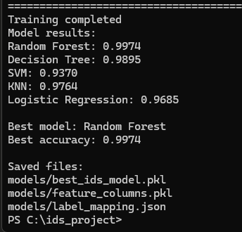
Model training script showing accuracy scores for all five classifiers

3.9.2 Best Performing Model: Random Forest
The Random Forest classifier achieved the highest accuracy of 99.74%, making it the selected model for integration into the real-time IDS dashboard. Random Forest is an ensemble method that builds multiple decision trees during training and outputs the majority vote for classification, which makes it highly robust against overfitting and effective for multi-class network traffic classification.
The trained Random Forest model was saved to disk and loaded by the Flask-based monitoring dashboard on the Monitoring VM for real-time traffic classification.

3.10 DASHBOARD DEVELOPMENT
The final phase of development involved building and deploying a real-time Intrusion Detection System dashboard using Python's Flask web framework. The dashboard runs on the Monitor VM (192.168.188.132) within the simulated network.

3.10.1 Dashboard Project Structure
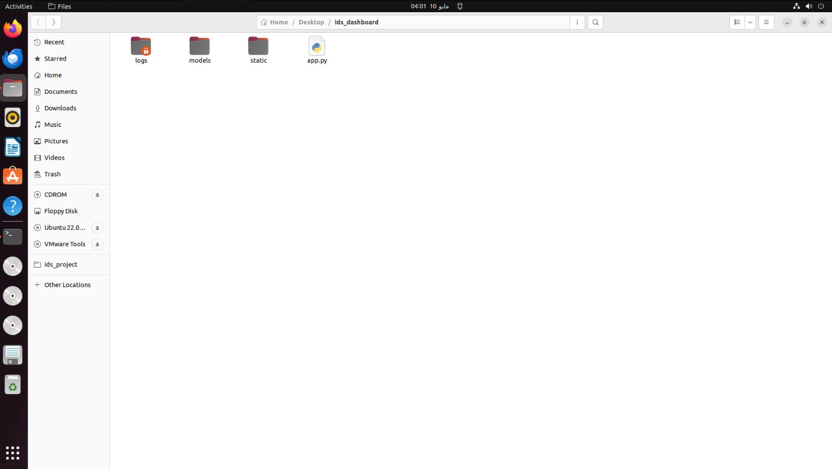
Dashboard Folder structure

3.10.2 Launching the Flask Server
The dashboard is launched by running app.py with sudo privileges on the IDS Monitor VM. Root privileges are required because the application uses raw packet capture (via Scapy) on the network interface, which requires elevated permissions.
Command used:
sudo python3 app.py
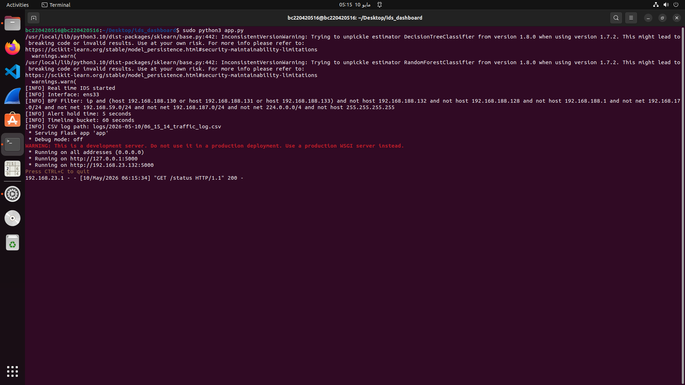
Terminal showing Flask app.py startup, including IDS configuration details and server binding
The server binds to all interfaces (0.0.0.0) on port 5000, making the dashboard accessible via http://192.168.188.132:5000. A new timestamped CSV log file is created automatically at each session start, ensuring that traffic logs from previous sessions are never overwritten.

3.10.3 Session-Based Log Management
One of the key functional requirements of the system was that each monitoring session must generate its own CSV file without overwriting previous data. This was implemented by naming log files with the timestamp of when app.py was launched.
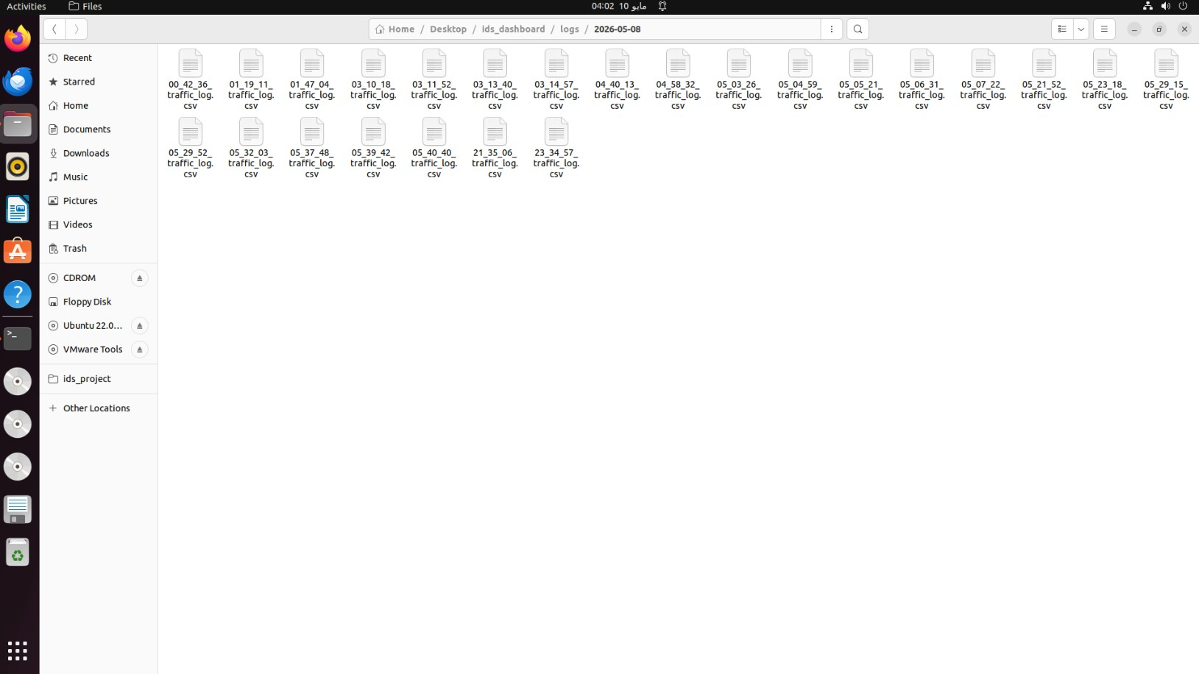
The logs directory is organized by date (e.g., logs/2026-05-08/), with each session producing a separate CSV file named by the session start time (e.g., 00_42_36_traffic_log.csv, 01_19_11_traffic_log.csv, etc.). This ensures a complete historical record of all IDS monitoring sessions is preserved.

3.10.4 Dashboard Features and Views

Main Overview Panel

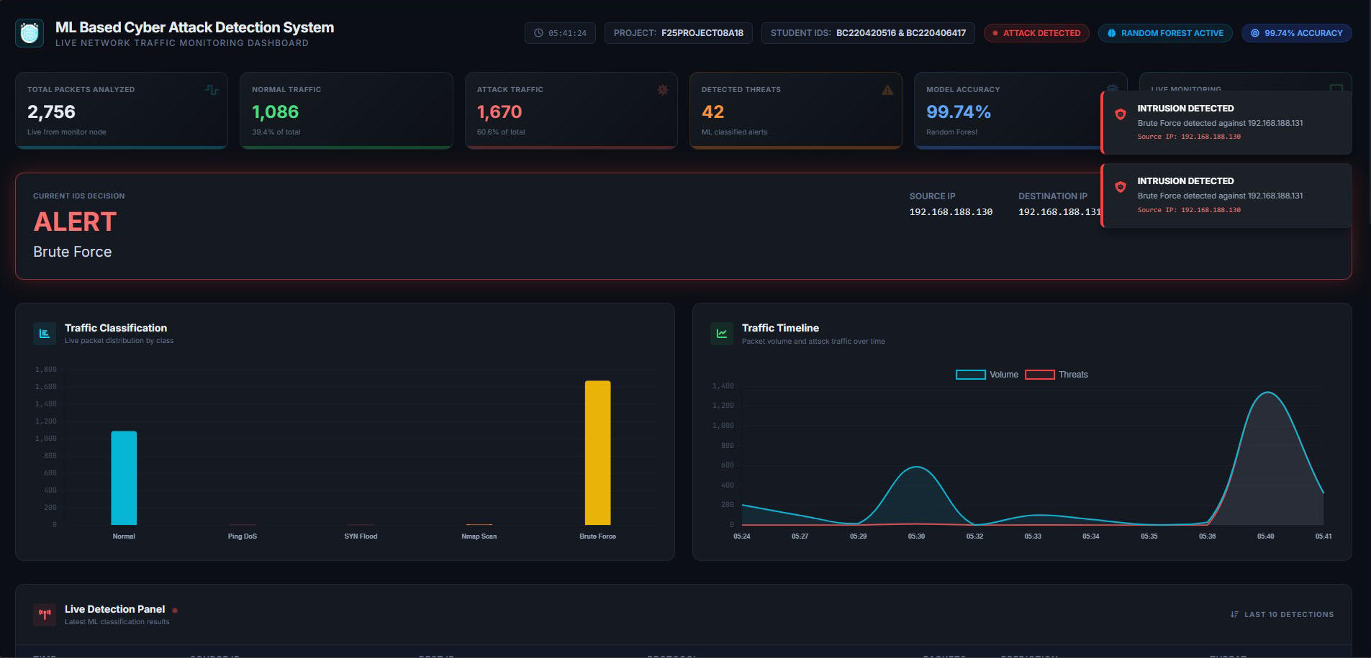

The main header panel displays live statistics including:
- Total Packets Analyzed: 2,756 (live from monitor node)
- Normal Traffic: 1,086 packets
- Attack Traffic: 1,670 packets
- Detected Threats: 42 ML-classified alerts
- Model Accuracy: 99.74% (Random Forest — Active)
- Current IDS Decision: ALERT: Brute Force (when attack detected)

Traffic Classification Chart
A bar chart displays the live distribution of traffic by class: Normal, Ping DoS, SYN Flood, Nmap Scan, and Brute Force. This provides an at-a-glance view of what types of traffic are present in the network during the current session.

Traffic Timeline
A time-series chart grouped in 1-minute intervals shows Volume (total packets) and Threats (attack packets) over time. This allows the analyst to identify when attacks began and how they evolved.

Live Detection Panel

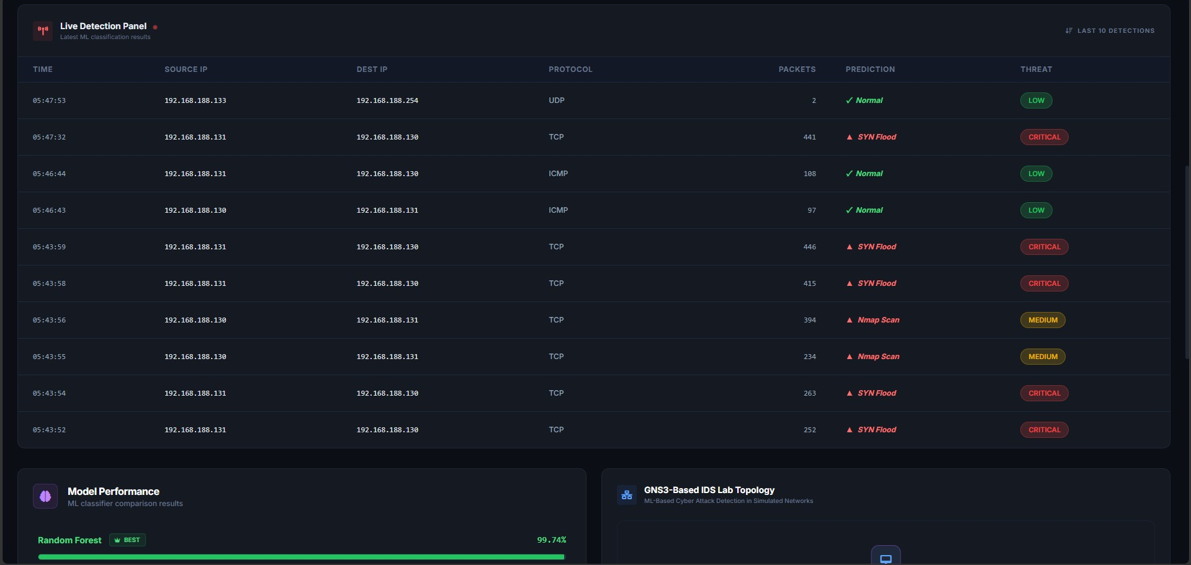

The Live Detection Panel shows the 10 most recent ML classification results in tabular format. Each record includes:
- Timestamp of the traffic window
- Source and Destination IP addresses
- Protocol (TCP, UDP, ICMP)
- Packet count in the window
- ML Prediction label (Normal, SYN Flood, Nmap Scan, Brute Force, Ping DoS)
- Threat level badge (LOW, MEDIUM, CRITICAL)

Model Performance Panel
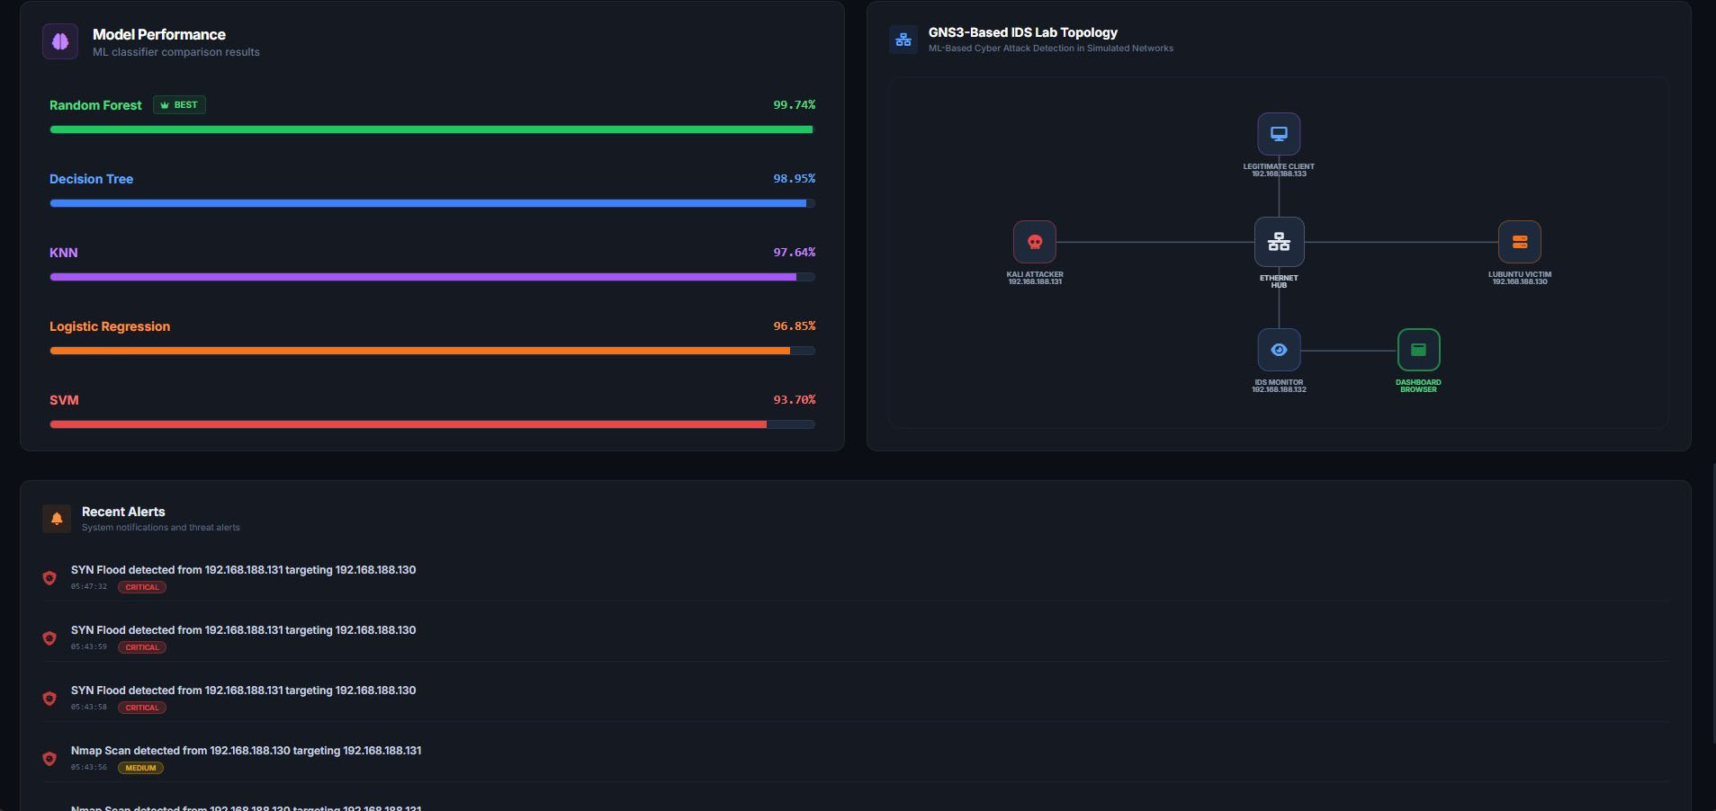

- The Model Performance section displays a visual comparison of all five trained ML classifiers with their respective accuracy scores.
- The dashboard also renders an interactive visual representation of the simulated network topology, showing all with their IP addresses. This provides network context alongside the detection data.

Recent Alerts Panel
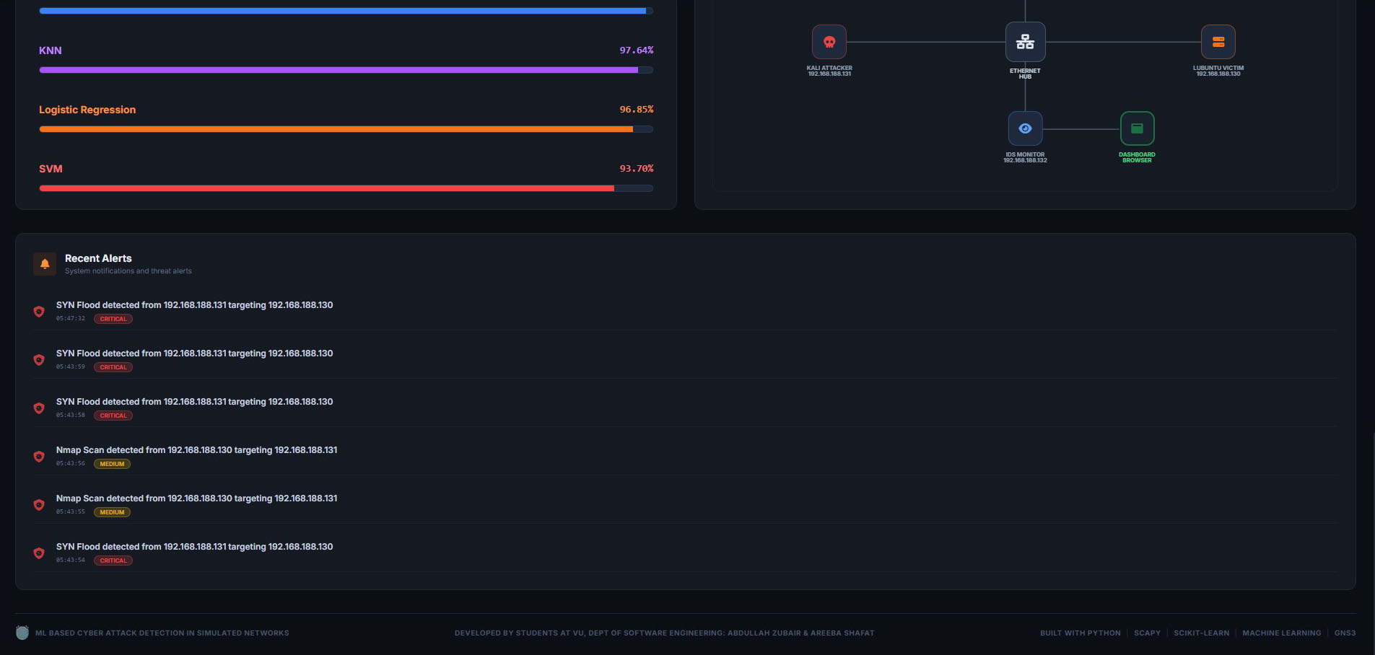
The Recent Alerts section lists all attack events detected during the session with timestamp, attack type, source and destination IPs, and severity classification.
Safe State
Dashboard shows green indicators and normal traffic statistics

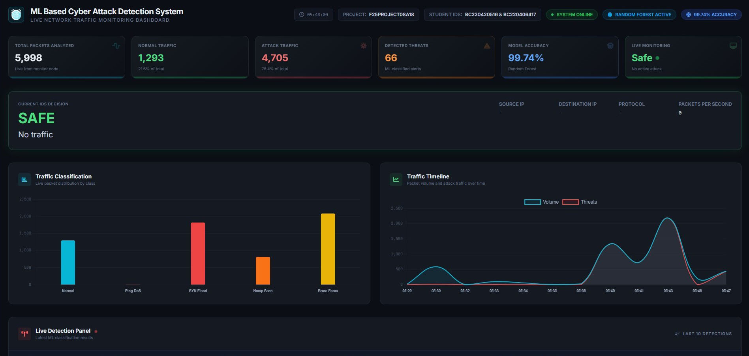

3.11 DEVELOPMENT SUMMARY
The development phase successfully implemented and verified all planned components. The Random Forest classifier, achieving 99.74% accuracy, was selected as the primary detection model integrated into the real-time dashboard. The development phase successfully demonstrates that a machine learning-based Cyber Attack Detection System can effectively detect and classify multiple types of cyber attacks including SYN Flood, Brute Force, Nmap Scanning, and Ping DoS within a realistic simulated network environment, providing real-time alerts and comprehensive traffic monitoring through a web-based dashboard.
REFERENCES

- K. Scarfone and P. Mell, Guide to Intrusion Detection and Prevention Systems (IDPS), NIST Special Publication 800-94, National Institute of Standards and Technology, 2007. https://csrc.nist.gov/pubs/sp/800/94/final
- Wireshark Foundation, Wireshark User’s Guide. https://www.wireshark.org/docs/wsug_html/
- Scapy Project, Scapy Documentation: Introduction. https://scapy.readthedocs.io/en/latest/introduction.html
- F. Pedregosa et al., Scikit-learn: Machine Learning in Python, Journal of Machine Learning Research, vol. 12, pp. 2825-2830, 2011. https://jmlr.org/papers/v12/pedregosa11a.html
- Scikit-learn Developers, RandomForestClassifier Documentation.
https://scikit-learn.org/stable/modules/generated/sklearn.ensemble.RandomForestClassifier.html
- L. Breiman, Random Forests, Machine Learning, vol. 45, pp. 5-32, 2001. https://link.springer.com/article/10.1023/A:1010933404324
- Scikit-learn Developers, Model Evaluation: Metrics and Scoring. https://scikit-learn.org/stable/modules/model_evaluation.html
- Canadian Institute for Cybersecurity, University of New Brunswick, CICIDS2017 Dataset. https://www.unb.ca/cic/datasets/ids-2017.html
- Pandas Development Team, pandas Documentation. https://pandas.pydata.org/docs/
- Pallets Projects, Flask Documentation. https://flask.palletsprojects.com/
- Joblib Developers, Joblib Documentation: Persistence. https://joblib.readthedocs.io/en/latest/persistence.html
- Matplotlib Developers, Matplotlib Documentation. https://matplotlib.org/stable/index.html

THANK YOU

